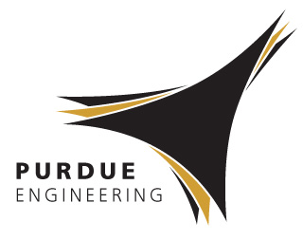 | Upcycling of Waste Plastic into Valuable Energy Storing Carbons  Vilas G. Pol  Associate Professor of Chemical Engineering,  Purdue University, West Lafayette, IN 47907, USA  https://engineering.purdue.edu/ViPER/index.html | 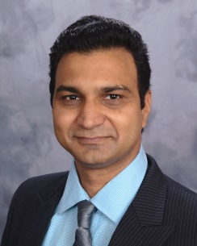

Abstract

Globally, around 400 million tons of waste plastic is generated every year. Out of which, less than 10% waste plastic is recycled and remaining goes to landfills and oceans littering our ecosystem. Conventional systems for accumulating recyclables produce combinations of unsorted plastics. Unsorted plastics are problematic to recycle due to their diverse chemical compositions. Sorting or shipping of unsorted plastics to developing countries is uneconomical. Considering these drawbacks, Pol developed ‘Upcycling’ process that converts valueless plastic waste feedstock into highly valuable energy storing carbon spheres, carbon sheets and carbon nanotubes in an environmentally benign way. Due to their unique physical properties, these upcycled products are used in rechargeable lithium- and sodium-ion batteries as anode electrodes. This EEE seminar will demonstrate plastic remediation processes to create high capacity, safer electrode materials, physico-chemical characterization, battery testing and life cycle analysis.

Biography

Dr. Vilas Pol is Associate Professor at Purdue University’s School of Chemical Engineering, USA. He earned his B. Sc., M.Sc., and M. Phil. degrees from Pune University, India and Ph. D. from Bar-Ilan University of Israel. Pol has 17 years of research experience in the fields of materials chemistry, environmental- and electrochemical- engineering. At Purdue, Pol leads ViPER (Vilas Pol’s Energy Research) laboratory that produces unique anode and cathode materials and tests them for Li-, Na-, K-ions and Li-S batteries. He has authored/co-authored 130 research publications (h index 38), 4 book chapters and an inventor on 18 US patents/applications. He is ACS Grand Prize winner, MRS science as art first prize, Intel prize, 2013 British Carbon Society’s Brian Kelly award and is a ‘Gold Medalist’ in Sports. In 2015, he developed one of the 100 most technologically significant new product, which won R and D 100 award. In 2016, he received American Institute of Chemical Engineer’s ‘Sustainable Engineering Forum Research’ Award.

