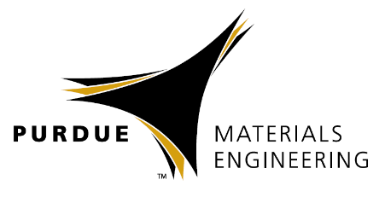
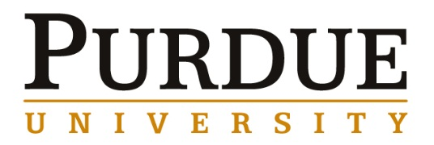

Professor Philip Eisenlohr

Chemical Engineering and Materials Science,
Michigan State University

DAMASK as a tool to solve coupled problems in crystal plasticity

Materials Engineering
Spring 2018

MSE 690
Seminar
Series

March 23,
2018

3:30 pm Coffee
3:45 pm Seminar
ARMS

Abstract
The Düsseldorf Advanced Material Simulation Kit (DAMASK) started out as a modular framework for crystal plasticity more than a decade ago and has recently been advanced to solve coupled multi-field problems on regular grids with efficient Fourier space-based solution schemes. The talk will present some details on the strategies and possibilities for multi-mechanism and multi-physics coupling offered by the current state of development. A soft and dilatational material model and its use to simulate non-compact geometries as well as its help in understanding the importance of subsurface grain structure on surface strain evolution will serve as an example for a multi-mechanism setup. Thermo-mechanically coupled simulations of the stress evolution in thermally strained ¯-Sn films on a substrate and in polycrystalline hexagonal Ti during temperature changes will illustrate the capabilities in a multi-physics setting.

Biography
Associate Professor Philip Eisenlohr studied materials science and engineering at Universität Erlangen–Nürnberg, Germany, and received his PhD in 2004. Dr. Eisenlohr was research group leader at the Max-Planck-Institut für Eisenforschung GmbH, Düsseldorf, Germany, before joining the Chemical Engineering and Materials Science department Michigan State University in 2013.
He teaches classes in the field of physical metallurgy and computational materials science and has a research focus on mechanics of micro/nano-structured materials, with a particular interest in basic science of plastic deformation mechanism in metals combined with the advancement of associated simulation methodologies. His major research target is the acceleration of materials design through Integrated Computational Materials Engineering (ICME) based on physically accurate descriptions of governing mechanisms. Investigated material classes include titanium alloys, tin and tin-based solders, niobium, and high-strength (twinning-induced plasticity) steels.

