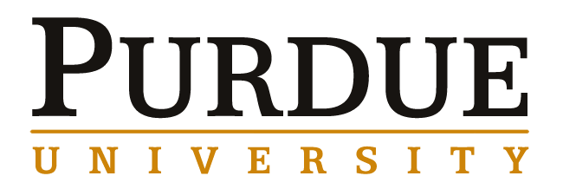
Analytical Chemistry Seminar

Tuesday, December 07, 2021 ~ 3:30 to 5:00 PM

Zoom Link:
https://purdue-edu.zoom.us/j/99162053971?pwd=TUtPNktsMEFPSUlrOXg1Z0J0bEczdz09

Meeting ID: 991 6205 3971
Passcode: 492336

“SARS-COV-2: Respiratory Aerosols, Droplets and Airborne Transmission”

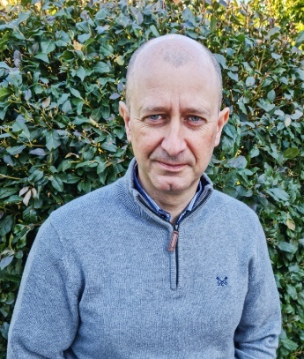
Professor Jonathan Reid
University of Bristol, School of Chemistry
Abstract:
Aerosols of respirable size (<10um diameter) are exhaled when breathing, speaking and coughing and can transmit respiratory pathogens. Improved quantification of number and mass exhalation rates could support estimates of viral shedding and assessments of transmission risk. Previous studies report aerosol concentrations in an exhaled plume; we will present absolute exhalation rates from measurements of minute ventilation using cardiopulmonary exercise testing with exhaled particle concentrations. Measurements are made in a zero-background space to ensure all aerosols detected originate from the participant, reporting mass exhalation rates for children (aged 12-14) and adults (19-72) when breathing, speaking, singing and exercising. We will also report measurements of hygroscopic response of exhaled aerosol along with studies of evaporation rates and phase behaviour. Aerosol and droplet size, composition and moisture content are dynamic with both drying rapidly once exhaled from the highly humid respiratory tract and we will review the interplay of dynamic and equilibrium properties in governing the distance of transmission of droplets. We will also report new measurements of the survival of SARS-COV-2 in aerosol using a novel single particle approach in a CL-3 laboratory, examining the dependence of infectivity on relative humidity and temperature.

