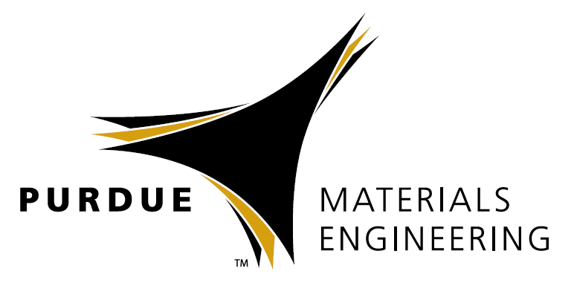


Edwin Chan, Ph.D.
Project Leader, Materials Science and Engineering Division
National Institute of Standards and Technology

Bubbles and BBs - Nontraditional Approaches
to Study Fracture of Soft Materials

Abstract
Understanding the fracture behavior of soft materials such as gels and polymer glasses is important in applications ranging from drug release to impact mitigation. This talk will highlight the two nontraditional measurement approaches to study the fracture of soft materials at different deformation rates. The first part of the talk will focus on using cavitation rheology to study the quasi-static fracture behavior of a biopolymer gel. Specifically, we show that gelatin gels display a poroelastic type fracture mechanism that scales with the concentration of the gel, and provides a unique mechanism that significantly enhances the fracture energy of the gel. The second part of the talk with focus on the high rate fracture of polymer glasses used in impact mitigating applications. Here, we will present a new measurement platform that can study the fracture properties of polycarbonate films by puncturing them with microparticles at ballistic rates.
Biography
Edwin P. Chan is the currently the Project Leader of the Mechanics of Polymers and Interfaces Project in the Materials Science and Engineering Division at the National Institute of Standards and Technology (NIST). His current research focuses on the impact resistance of soft architectured materials, fracture properties of polymer gels, and adhesion of bottlebrush networks.
Edwin earned a B.S. in Materials Science & Engineering from the Pennsylvania State University in 2000, an M.S. in Materials Science & Engineering from the Massachusetts Institute of Technology in 2003, and a Ph.D. in Polymers Science & Engineering from the University of Massachusetts Amherst in 2007. His Ph.D. research was on the adhesion and mechanics of structured soft elastomers. Prior to joining the technical staff, Edwin was a National Research Council Post-doctoral fellow in the Polymers Division at NIST (2008-2011). He has over 50 publications, 3 book chapters and 4 patents.

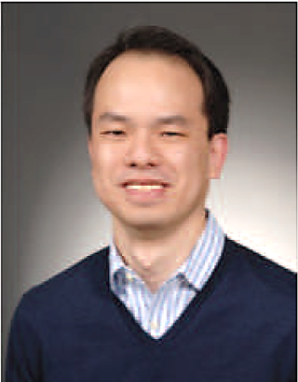

Materials Engineering
Special Guest Speaker

July 27, 2018
ARMS 1028

10:30 am Coffee
11:00 am Seminar

