
Kaustubh N. Kulkarni, Associate Professor,
IIT Kanpur

Investigations of Interdiffusion and Phase Equilibria in Multicomponent Alloys

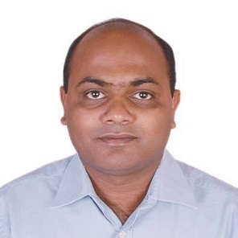
Materials Engineering
Fall 2018

MSE 690
Seminar
Series

Friday
October 19,
2018

3:30 pm Coffee
3:45 pm Seminar
ARMS 1010

Abstract

Diffusion in solids controls many metallurgical processes including various phase transformations, homogenization and joining of materials. Control of interdiffusion is also crucial aspect of material systems that operate at elevated temperatures as they may experience degradation in performance due to alloy loss or change of microstructure caused by interdiffusion of various alloying elements during service. Most of the applications are based on multicomponent systems containing three or more components. However, there is a severe lack of data on diffusion in multicomponent solids. A brief theoretical background on multicomponent diffusion will be presented at the beginning of this talk followed by experimental methodologies used to determine interdiffusion coefficients in the multicomponent systems. Experimental interdiffusion studies carried out in various systems will be presented including the ternary Ti-Al-Mo, Ti-Al-Nb, quaternary Fe-Ni-Co-Cr and quinary Fe-Ni-Co-Cr-Mn systems. Diffusional interactions or the effect of one diffusing species on the diffusion of the others is an important aspect of multicomponent diffusion. Its manifestation in the form of uphill diffusion and zero flux planes will be highlighted. Use of the interdiffusion data, especially the diffusional interactions, in designing new alloys and processes will be illustrated with couple of examples. Experimental determination of quaternary isotherm of Fe-Ni-Co-Ni system at 950 °C using multiphase diffusion couple will also be discussed.

Biography

Dr. Kaustubh Kulkarni is currently Associate Professor in the department of Materials Science and Engineering at IIT Kanpur. He has done his PhD in Materials Engineering from Purdue University in 2008 and his BE in Metallurgical Engineering from College of Engineering, Pune in 2002. Prior to joining IIT Kanpur, he worked in Automotive Research Association of India and in GM Global R&D, Bangalore. Dr. Kulkarni has several publications and two US Patents on his name. His research theme focuses on investigations of interdiffusion and phase equilibria in multicomponent systems and utilizing this fundamental information for designing new alloys and processes. At IIT Kanpur, Dr. Kulkarni has established many industrial collaborations including those with GM, GE and ARAI.

