

Analytical Chemistry Seminar

Tuesday, October 26, 2021
3:30 PM, WTHR 320

“Structure in Situ: Characterizing a Protein Lattice Involved in Carbon Fixation””

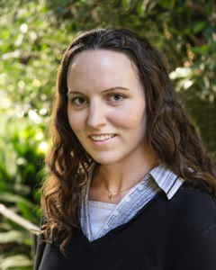

Dr. Lauren Ann Metskas
Assistant Professor of Biology and Chemistry
Purdue University
Abstract
Roughly 20% of bacteria employ microcompartments to sequester dangerous or inefficient enzymatic processes inside a semi-permeable protein shell. In addition to their importance for prokaryotic metabolism, microcompartments have recently become targets for bioengineering due to their ability to assemble and function outside their native host. However, interior organization and some functional mechanisms remain unknown. Here, we employ cryo-electron tomography to image intact alpha-carboxysomes, a microcompartment responsible for carbon fixation. High-resolution processing has enabled us to solve an in situ structure of the primary cargo enzyme, RuBisCO; identify its interaction partners; and characterize a novel ultrastructure not previously identified. I will discuss these technical advances and their biological results, and present ongoing methods development in correlative techniques to add non-structural information to our in situ protein visualization.

