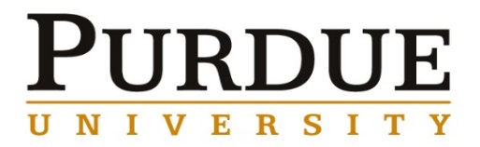
Lionel Vargas-Gonzalez, Ph.D.
Team Leader, Ceramic Synthesis and Processing
Ceramic and Transparent Materials Branch U.S. Army Research Laboratory

Novel Materials and Processes for Dismounted Soldier Protection
Abstract
The threats for Dismounted Soldiers are ever evolving, necessitating the need for the technological advancement of survivability systems; the majority of advancements to survivability have come through the development and implementation of novel material technologies (from steel shells to synthetic fibers, and improved advanced ceramics). Manufacturing technologies developed through the highly successful Army Manufacturing Technology (ManTech) helmet program (2006–2009) and ultra-high molecular weight polyethylene (UHMWPE) fiber improvements generated from collaboration between industry and PEO Soldier eventually led to the implementation the UHMWPE-based Enhanced Combat Helmet (ECH), which yielded a historical improvement in ballistics and is the first helmet system to include a small arms penetration specification. From 2011–2014, the Army and OSD ManTech programs invested a combined ~$10M with the goal of developing manufacturing techniques to produce 10% body armor. Collaboration with the ceramic industrial base yielded new ceramic formulations, including compositions using blended powder chemistries, grain boundary additives, and multi-scale structures. These improvements, combined with novel composite materials, designs, and armor integration strategies led to transitions to the fielding of 7–10% lighter plates for the U.S. Military (for both USSOCOM and big Army).
Further improvement to mass-efficiency for Soldier protection materials have been frustratingly difficult. Increasing demands for reductions in dismounted Soldier armor system weight and the ever-evolving emergent threat are placing extreme pressure on the armor S&T community to develop viable solutions. The boron carbide (B₄C) and silicon carbide (SiC) ceramics used for protective inserts are lightweight, theoretically dense, and highly pure, and even with the large investment in S&T, gains in performance have been marginal. ARL’s ceramic mission efforts are focused toward high risk, high reward approaches such as the synthesis and processing of novel superhard, lightweight ceramic formulations (such as boron suboxide and aluminum magnesium boride) and the processing science for implementation of structural heterogeneity in ceramics at multiple length scales. A discussion of the advancements in the state of the art for Soldier head and torso protection, and the current research approaches and challenges for improvement of materials will be presented.

Biography
Dr. Lionel Vargas-Gonzalez is the leader for the Ceramics Synthesis and Processing Team within the Ceramic and Transparent Materials Branch, U.S. Army Research Laboratory Weapons and Materials Research Directorate. He is a lead subject matter expert for dismounted Soldier ballistic protection materials and processes. At ARL, he has been involved in a variety of program efforts in lightweight materials (ceramics, metals, and polymer composites), surface science, dissimilar material adhesion, and processing science for head and torso armors. Dr. Vargas-Gonzalez led the materials integration, armor processing, laminate development, and ballistic characterization for the highly successful Army and DMS&T Body Armor ManTech programs. Laminate architecture designs developed under this effort demonstrated marked reduction in ballistic blunt trauma, and were implemented by several domestic and international armor integrators for both helmets and body armor. For his efforts under the armor program, he was a co-recipient of the DoD ManTech Defense Manufacturing Achievement Award in 2013. He was awarded the ARL Honorary Award for Engineering in 2015 for demonstrating a method of reducing head-borne non-penetrating ballistic blunt trauma by 84% through composite architecture design. He has been an author on 40 open literature publications, proceedings, and government reports and has been awarded one U.S. Patent for processing of theoretically-dense silicon carbide. He received a B.S. in Ceramic and Materials Engineering from Clemson University in 2004, and a Ph.D. in Materials Science and Engineering from the Georgia Institute of Technology in 2009. Following his post-doctoral appointment at ARL, he was converted to federal service in 2011.

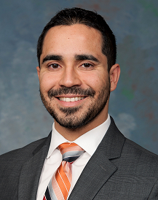

Materials Engineering
Fall 2017
MSE 690
Seminar
Series
November 6, 2017

3:30 pm Coffee
3:45 pm Seminar
ARMS 1010

