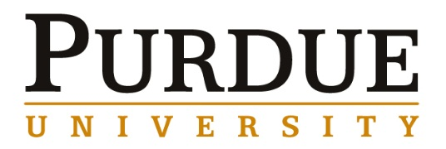

Professor Douglas P. Holmes
Mechanical Engineering
Boston University

Friday, April 21, 2017
Thursday, April 20, 2017
Time | Event | Location | Notes
Arriving late by shuttle | Union Club Hotel  101 N. Grant St. West Lafayette, IN 47906-3574  phone: 765-494-8900 fax: 765-494-8924 |  | Confirmation number  2918332

Friday, April 21, 2017
Time | Event | Location | Notes
8:00 – 9:15am | Breakfast with Materials Engineering Professors Lia Stanciu and Elliott Slamovich | Meet in Hotel Lobby | Prof. will pick up
9:30 – 10:00am | Lab Tour with Materials Engineering Graduate Student Mitchell Rencheck | Meet in ARMS 2300
10:00 – 10:30am | Meet with Materials Engineering Professor Jeffrey Youngblood | ARMS 2233
10:30 – 11:00am | Meet Materials Engineering with Professor Kendra Erk | ARMS 2222
11:00 – 11:30pm | Meet with Materials Engineering Professor Carlos Martinez | ARMS 2327
11:45 – 1:15pm | Lunch with Materials Engineering Graduate Students: Travis Thornell, Lisa Rueschhoff, Mitchell Rencheck, Yaohui Fan, Jason Bice, Hyeyoung Son and Alejandro Alcaraz | Another Broken Egg | Reservation  MSE
1:30 – 2:00pm | Meet with Materials Engineering Professor John Howarter | ARMS 2303
2:00 – 2:30pm | Meet with Mechanical Engineering Professor Adrian Buganza Tepole | ARMS 2303
2:30 – 3:00pm | Meet with Materials Engineering Professor Chelsea Davis | ARMS 2229
3:00 – 3:30pm | Meet with Materials Engineering Professor Department Head and Professor David Bahr | ARMS 2300
3:30 – 3:45pm | Seminar Prep | ARMS 1010
3:45 – 5:00pm | Seminar | ARMS 1010
 | Leaving after Seminar

