

Professor Douglas P. Holmes
Mechanical Engineering
Boston University

Elastogranular Mechanics in Fragile Matter
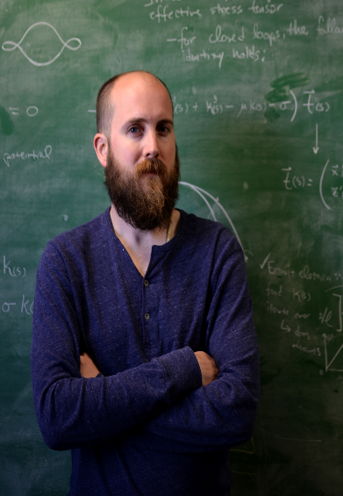
Abstract
The coupling of slender rods and disordered granular matter occurs during the growth of plant roots, the bending and buckling of oil pipelines and drill strings, and the creation of subterranean infrastructure with microtunneling and trenchless technology. These highly nonlinear interactions also present a means to develop jammable, amorphous metamaterials that are disordered on the scale of their local constituent units, yet result in remarkably strong macroscale ordered structures. Elastogranular jamming consists of the disordered coupling of granular media and slender structures to generate structural integrity. In this talk, we will first quantify the buckling of a partially inserted elastica into a bed of granular media, showing that beyond a critical penetration depth the beam buckles in a manner independent of the boundary conditions at its embedded end. We then investigate structure formation in planar elastogranular systems within a 2D array of beads. Elastica confinement and granular disorder-to-order transitions lead to the emergence of periodically folded structures with a characteristic length scale dictated by the packing fraction of the granular media. We examine the role of local granular order on the resulting elastica confinement, and granular reconfiguration. The resulting 2D elastogranular arrays provide a framework for amorphous mechanical metamaterials that enable pourable, jammed structures.
Biography
Douglas Holmes is an Assistant Professor in the Department of Mechanical Engineering at Boston University. He received degrees in Chemistry from the University of New Hampshire (B.S. 2004), Polymer Science & Engineering from the University of Massachusetts, Amherst (M.S. 2005, Ph.D. 2009), and was a postdoctoral researcher in Mechanical & Aerospace Engineering at Princeton University. Prior to joining Boston University, he was an Assistant Professor of Engineering Science and Mechanics at Virginia Tech. His group’s research specializes on the mechanics of slender structures, with a focus on understanding and controlling shape change. He received the NSF CAREER Award and the ASEE Ferdinand P. Beer and E. Russell Johnston Jr. Outstanding New Mechanics Educator award.

Materials Engineering
Spring 2017
MSE 690
Seminar
Series

April 21, 2017

3:30 pm Coffee
3:45 pm Seminar
ARMS 1010

