

Professor Amy Marconnet
Mechanical Engineering, Purdue University

Nanoengineering Materials for Thermal Transport

Abstract
Nanostructuring materials allows independent control of multiple materials properties. High conductivity materials such as carbon nanotube forests are useful as TIMs for dissipating power in electronic devices, while low conductivity materials like nanoporous silicon for thermal barrier coatings and enhanced thermoelectric performance. Beyond thermal transport, storage of thermal energy is critical for effective heat removal for applications involving highly-transient heat fluxes, and during material processing. Often to achieve the desired functionality, multiples materials are combined together to form heterogeneous composites. For example, in lithium ion batteries, the particulate active materials (with micro- and nano-scale features) are sandwiched between metal electrodes and polymer-based separators with microscale thicknesses to form macroscale battery cells. This seminar will discuss methods to push the thermal conductivity to the extremes by understanding and controlling the transport at the nanoscale and development of accurate and reliable experimental and analytical techniques for thermal characterization across multiple length scales. Further, I will highlight the integration of material synthesis with thermal property measurements and physics-based analysis to provide new avenues for improved materials and device performance.

Biography
Amy Marconnet is an assistant professor of Mechanical Engineering at Purdue University. She received a B.S. in Mechanical Engineering from the University of Wisconsin – Madison in 2007, and an M.S. and a PhD in Mechanical Engineering at Stanford University in 2009 and 2012, respectively. She then worked briefly as a postdoctoral associate at the Massachusetts Institute of Technology, before joining the faculty at Purdue University in 2013. Research in the Marconnet Thermal and Energy Conversion (MTEC) Lab integrates metrology and analysis of underlying transport mechanisms with design and development of nanostructured materials for heat transfer and energy conversion applications.
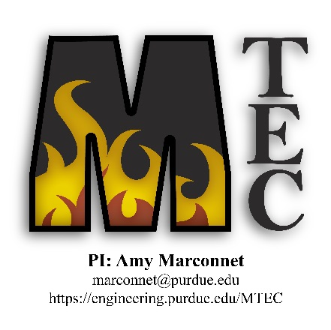

Materials Engineering
Fall 2016
MSE 690
Seminar
Series

September 11, 2017
3:45 pm Seminar
ARMS 1010

