

Chemistry Materials Colloquium

Thursday, January 13, 2022 4:30 PM WTHR 104

“Photoactivation for Polymerization, End-group
Functionalization, and Bioconjugation”

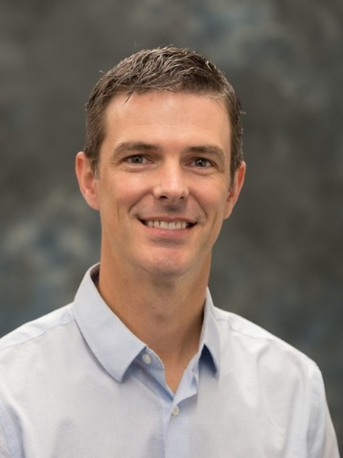

Brent S. Sumerlin
The George Bergen Butler Professor of Polymer Chemistry
Department of Chemistry
University of Florida

Abstract:

Relying solely on mild ultraviolet or visible irradiation of thiocarbonylthio compounds, a new avenue to polymer-protein conjugates, semi-telechelic polymers, and well-defined ultrahigh molecular weight (UHMW) block polymers has been developed. Using either a photocatalyst or relying on the direct activation of thiocarbonylthio end groups via photolysis, well-controlled polymers with high molecular weights that are unprecedented for controlled radical polymerizations have been achieved. This photomediated polymerization approach reaches number-average molecular weights in excess of 8.00 × 10⁶ g/mol with degrees of polymerization above 85,000, making these, to our knowledge, the highest molecular weight polymers ever achieved via reversible-deactivation radical polymerization. The utility of the technique is further demonstrated through the synthesis of block copolymers and polymer-protein conjugation.

