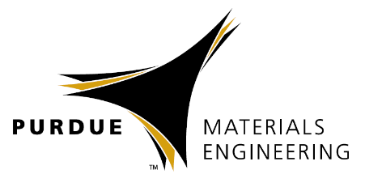
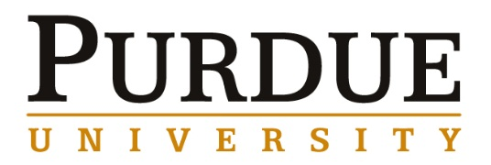

Professor Lihua Qian
School of Physics, Huazhong University of Science and Technology

Self-strengthening of bimetallic electrocatalysts for efficient CO₂-to-fuel conversion

Abstract
One promising way to relieve the surging consumption of fossil energy is to accomplish electrochemical carbon dioxide reduction (CDR) toward valuable chemicals and fuels. However, high overpotential to overcome thermodynamic stability of CO₂ molecules and sluggish reaction kinetics bring many negative effects, such as the catalysis deterioration and selectivity decay. In this talk, as a proof-of-concept experiment, we attempt to design bimetallic electrocatalysts with a self-strengthening behavior during the CDR procedure. Besides the long-term durability, positive evolution of surface composition in nanoporous bimetallic alloys simultaneously enhances the efficient conversion towards chemical fuels, and enables inhibiting hydrogen evolution reaction, a side reaction during the CDR. Novel protocol that can explore the self-strengthening activity on the electrocatalyst’s surface, as revealed in this study, shall offer an avenue to rationally design electrochemical catalysts that operate at high overpotential, and sustain the high activity and stability. This fundamental concept can be extended toward some other electrochemical reactions, such as hydrogen evolution reaction, nitrogen reduction reaction, and oxygen reduction reaction.

Biography
Dr. Qian received his Bachelor Degree in Materials Science from Northeastern University, Shenyang, China, in 1998. He obtained his Ph.D. degree in Materials Science from Institute of Metal Research, Chinese Academy of Sciences, in 2005. After graduation, he joined the Institute of materials research, Tohoku University, in Japan, as a Postdoctoral Researcher. Then, he worked as a Postdoctoral Researcher in University of Nevada Las Vegas in 2008. He is a Professor in School of Physics, Huazhong University of Science and Technology, China. His current researches focus on surface plasmon of metal nanostructure and its application, self assembly of nanoparticles, mechanical sensor, light manipulation in low-dimensional materials and nanoporous metals for sustainable energy. He has published more than 40 papers in international journals, such as ACS Nano, Scientific Reports, Advanced Energy Materials, Nano Research, Nanoscale, Applied Physics Letters, and the total citation is over 2000 times. He serves as an editorial board member of “Journal of Advanced Optics and Photonics”.

Friday, April 26, 2019

10:30 am Coffee
10:45 am Seminar
ARMS 1028

Materials Engineering
Special Guest
Speaker

