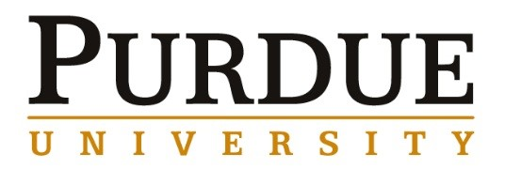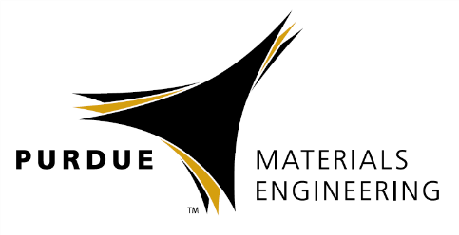
Valerie L. Wiesner
NASA Glenn Research Center, Cleveland, Ohio

Enabling Next-Generation, Efficient Aircraft Engines with Protective Ceramic Coatings Resistant to Molten Particulate Damage

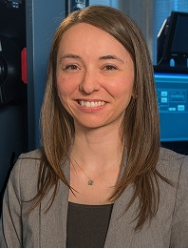
Abstract

In order to improve fuel economy in commercial aircraft, ceramic matrix composites (CMCs) are considered a leading material system to replace metal-based turbine engine components due to their lower density and high-temperature capabilities compared with conventional structural materials. However, silicon-based CMCs are susceptible to oxidation and corrosion in the harsh combustion environment found in air-breathing turbine engines. Environmental barrier coatings (EBCs) are being developed to protect and to improve the durability of underlying CMC components in hot-sections of engines. The implementation of robust EBCs is threatened by sand, volcanic ash and other particulate debris, which are regularly ingested by aircraft engines. At target operating temperatures of future CMC-based aircraft engines (>1200°C), the ingested particulates melt, resulting in molten deposits with compositions corresponding to calcium-magnesium-aluminosilicate (CMAS). Molten CMAS behaves like a viscous melt that can infiltrate and chemically interact with protective coatings, ultimately causing premature failure of ceramic-based engine components. In support of NASA’s Aeronautics Research Mission, NASA Glenn Research Center has developed and assessed a variety of candidate EBC materials to protect ceramic-based components for use in future, highly efficient turbine engines. A summary of current CMAS/EBC research activities, along with an overview of research in the Materials and Structures Division at NASA Glenn, will be shared.
Biography

Dr. Valerie Wiesner is a Research Materials Engineer in the Ceramic and Polymer Composites Branch at NASA Glenn Research Center in Cleveland, Ohio. Upon completing her Ph.D. in materials engineering from Purdue University in 2013, she has held the position of lead investigator for the Calcium-Magnesium Aluminosilicate (CMAS) and Environmental Barrier Coating (EBC) Task, while also more recently serving as inter-center liaison for materials and structures at NASA Glenn and NASA Langley Research Center in Hampton, Virginia. She has co-authored eight peer-reviewed journal publications, a technical handbook chapter and over 40 technical presentations and proceedings at conferences. She serves as secretary of the American Ceramic Society (ACerS) Engineering Ceramics Division and is a member of several committees within ACerS and ASM International. She has been an active member of the International Forum for Aviation Research, which is a global aeronautics research establishment comprised of 26 government organizations. Prior to graduate school, she worked as an English teacher and translator for the Tokyo Metropolitan Board of Education in Japan. She graduated from Carleton College in Northfield, Minnesota, with a bachelor’s degree in physics and a concentration in Japanese in 2008.

Materials Engineering
Special Guest
Speaker

Friday, August 17th,
2018

10:30 am Coffee
11:00 am Seminar
ARMS 1103

