This QRC provides the basic steps to add an approver or watcher or delete an approver or watcher that was manually added to the approval flow.

Adding an Approver or Watcher
Tips: An Approver must take action for the requisition to move along in the approval flow. A Watcher does not need to take action for the requisition to move along the approval flow. Both approvers and watchers receive an email notification and the item appears in the To Do section on their home dashboard in Ariba.
Click Show Approval Flow | 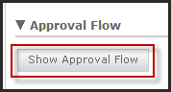
Click the down arrow button where you would like to add the person or group. | 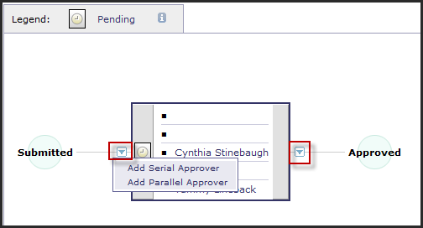
Serial Approval is before or after. | 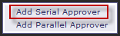
Click the down arrow, a list of recent people or groups will be listed. To add someone that is not in the list, click Search for more… | 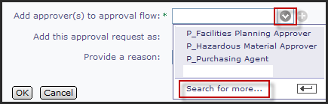
Select the type of search needed. Name used in this example.  Enter the last name  Click Search | 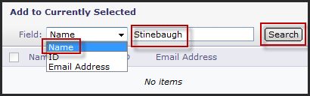
Click the check box next to the name to be used  Click Done | 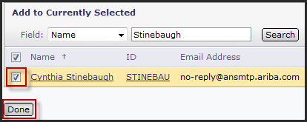
Determine if the person should be an Approver or a Watcher  Enter a reason for adding this approver.  NOTE: This information will appear when hovering over the approval node. | 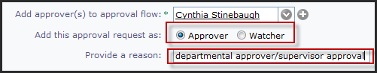  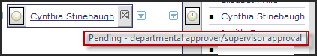
Parallel Approvals are happening at the same time.  NOTE: The only place to add a parallel approver is the beginning of the approval flow. | 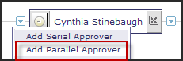
Select your Approver, see above how to search.  Select Approver radio button  Enter a reason for adding this approver.  NOTE: This information will appear when hovering over the approval node. | 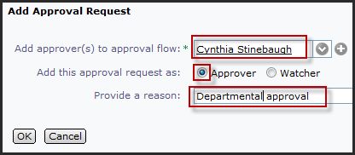
Adding a serial or parallel approver or watcher has been completed.
Deleting an Approver or Watcher
NOTE: Only an Approver or a Watcher that was manually added may be deleted. In addition if the approver has already approved the requisition they may be not be deleted.
When viewing the approval flow, any manually added approvers or watcher will have an “X” to the right of the name.  Click the “X” to delete the approver or watcher. | 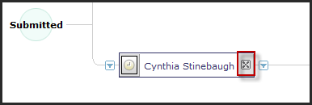
Click OK to delete approver or watcher.  The approver or watcher is removed from the approval flow | 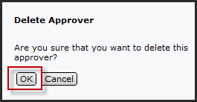
Deleting an approver or watcher has been completed.

