This QRC provides the basic steps to create a requisition. Full approval of a requisition is required before a Purchase Order (PO) is generated and sent to the supplier. You can create a requisition by adding catalog items or by adding non-catalog items if you are requesting a service or items not found in a catalog. It is recommended that you use one requisition for catalog items, and a separate requisition for non-catalog items.
Ariba sends a lot of emails. Requesters are encouraged to review the Edit Email Notifications in Ariba QRC to reduce the number of emails that will be received. If you use the same account number or the same ship-to address regularly review the Setting Profile Accounting and Shipping/Delivery Information in Ariba QRC.

Log in to Ariba
Access Ariba from the Employee Portal. | http://www.purdue.edu/employeeportal/  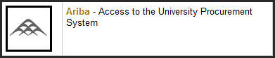
Log in using Purdue career account ID and password. | 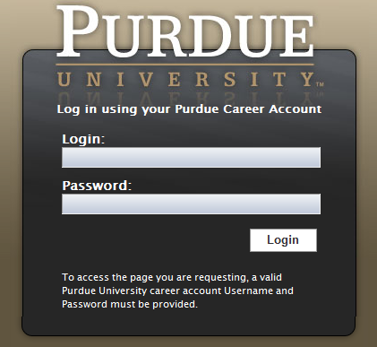

Create Requisition
From the Home Tab, click Requisition under the Create menu. | 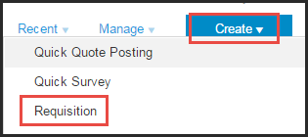
Instructions for adding items from a catalog, by category, by supplier or contract, or punch-out are found in Add Items to a Requisition – Catalog (Inlcuding University Stores) section.
Instructions for adding a non-catalog item is found in the Add Items to a Requisition – Non-Catalog section.

Add Items to a Requisition - Catalog (Including University Stores)
This section will focus on selecting items from CIF/hosted catalogs, by category, by supplier or punch-out catalog.
- First type of catalog we have is a CIF/hosted catalog items are searched for and added to requisition within Ariba.
- Second type is a Level 1 Punch-out catalog, all searching and adding items is done on the supplier’s punch-out website.
- Third type is a Level 2 Punch-out catalog, searching can be completed in Ariba. When ready to add the item to the requisition user punches out the supplier’s website.
From the catalog tab, locate items:  - Search catalogs for items using the Search box.  - Browse by Category by selecting a category from the list.  - Browse by Supplier by selecting the link.  - Go directly to a supplier’s Punch-out Catalog by clicking the supplier’s name with the punch-out icon (). |  | 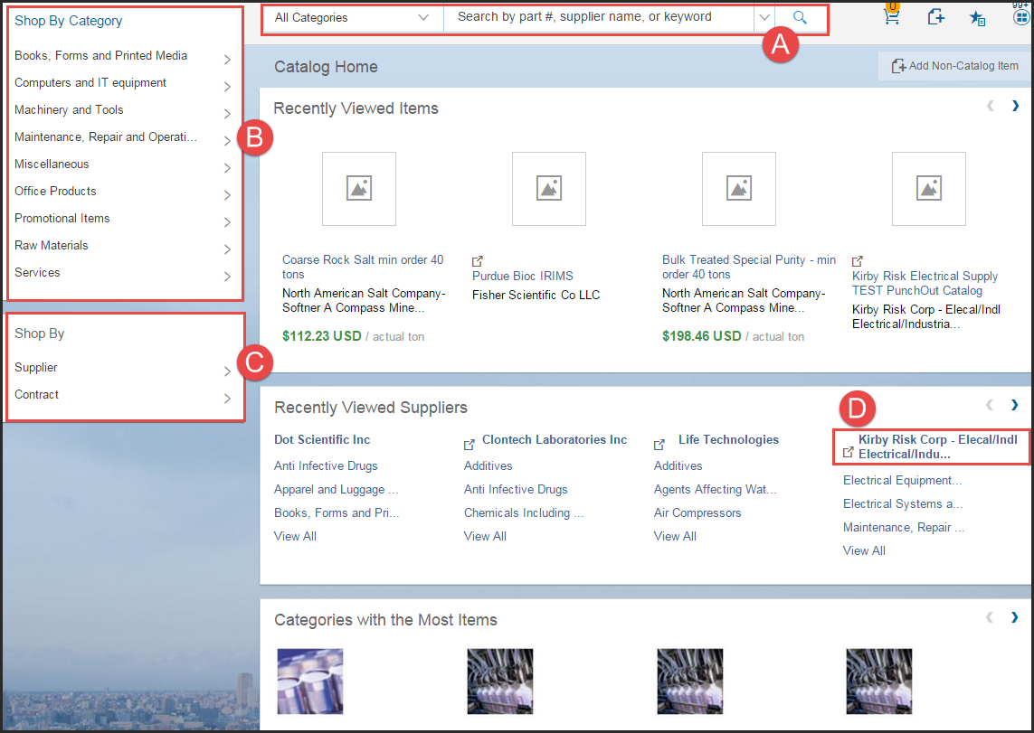
- Search catalogs for items using the Search box.  Enter a description, part number, or the material number (University Stores).  Results will appear from hosted catalogs (hosted catalogs appear on the all suppliers page without an icon next to the name), locate desired item, enter quantity, and click Add to Cart. |  | 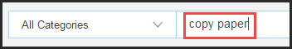  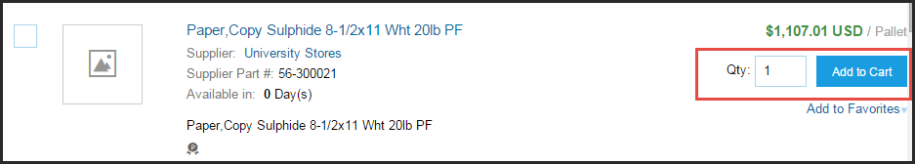
- Browse by Category by selecting a category from the list.  Select category and drill down in the category needed until the item is found. In this example Maintenance, Repair opens up Distribution and Conditioning then select Misc. Industrial Pumps and compressors.  Update the quantity needed and click Add to Cart. |  | 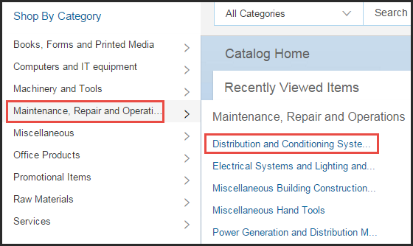    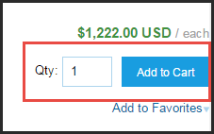
- Browse by Supplier by selecting the link.  One specific supplier may be chosen or click View All Suppliers to see a list. |  | 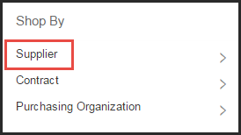  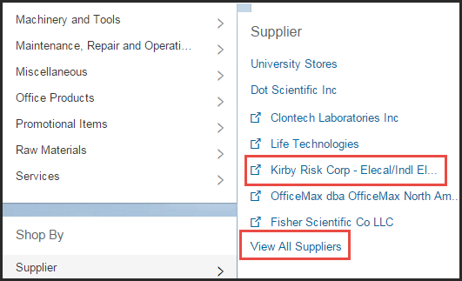
- Go directly to a supplier’s Punch-out Catalog by clicking the supplier’s name with the punch-out icon ().  Click Buy from Supplier. |  | 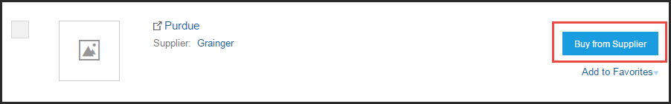
Browse for items in the supplier’s Punch-out site. Each supplier’s Punch-out site will be structured differently.  Generally, a search for specific items can be conducted by using the search function, or browse by category. |  | 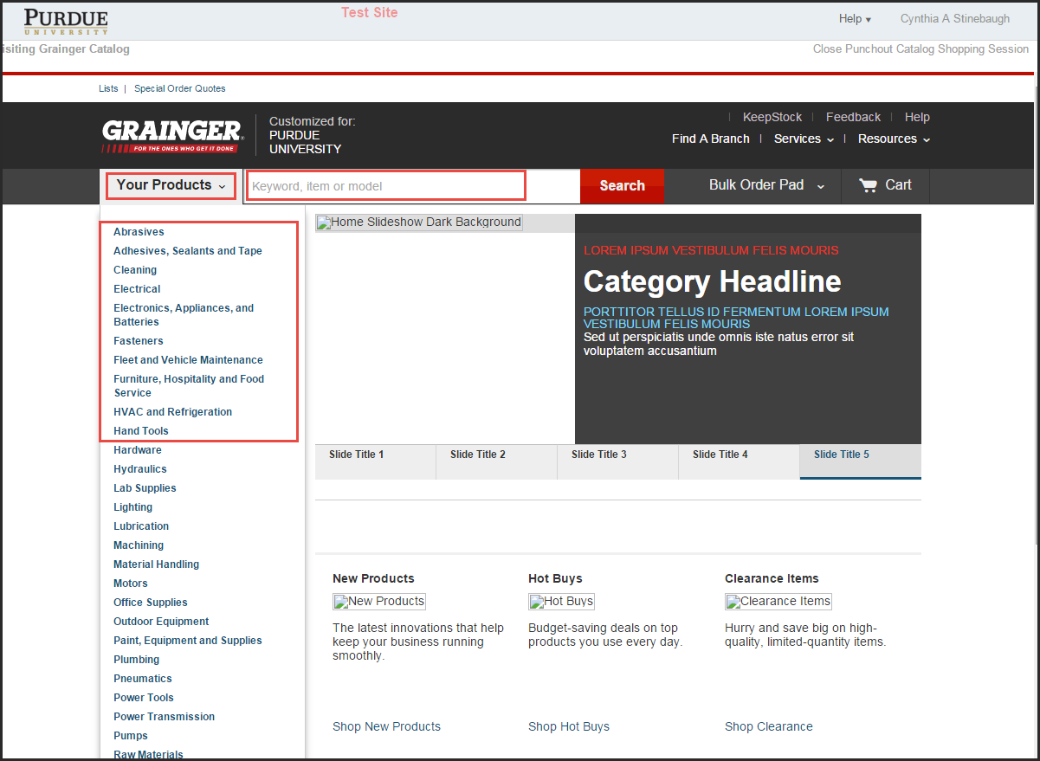
Once desired item(s) is located, enter the quantity of that item, and click Add to Cart.  Note: Catalogs that list multiple items in a list, will allow comparisons, by clicking the checkbox next to the items and then clicking Compare. |  | 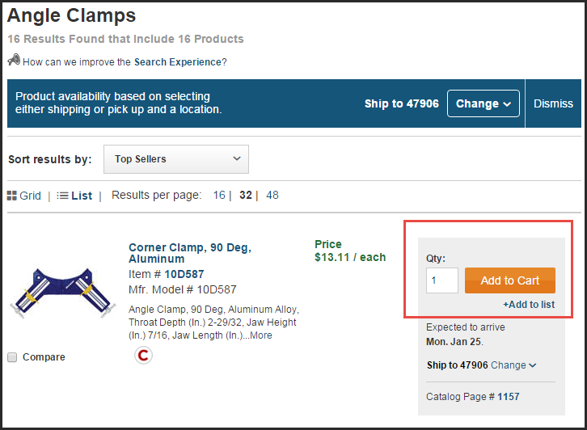
Click View Cart |  | 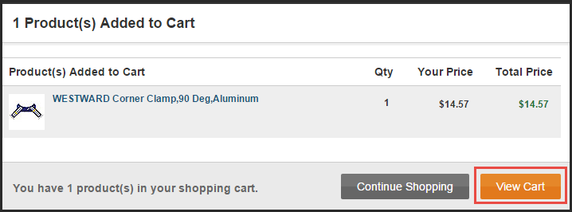
Click Submit Cart. |  | 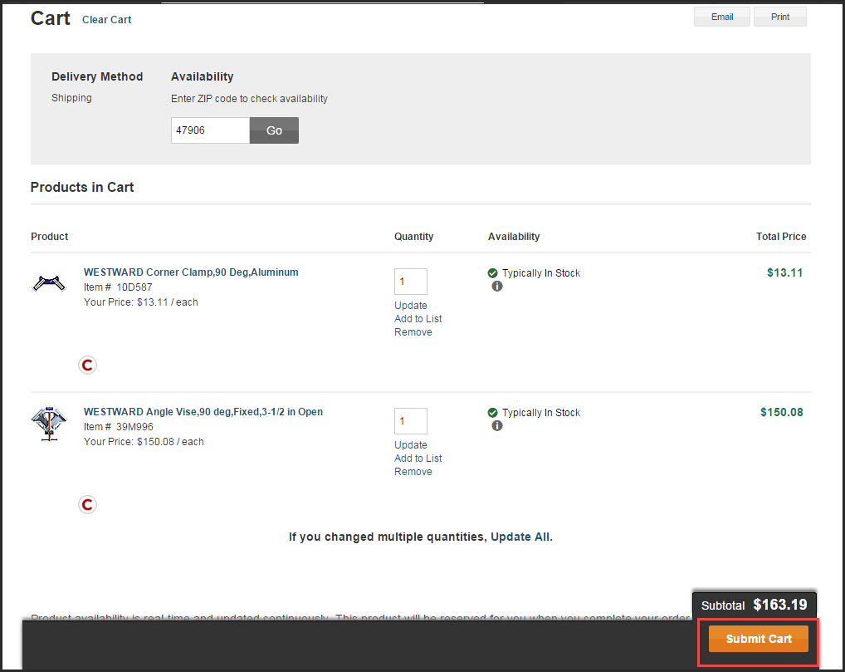
If all items have been added to the requisition, skip to the Submitting the Requisition section.
Best Practice is not to mix catalog and non-catalog line items on the same requisition.
Add Items to a Requisition – Non-Catalog
A search of the catalogs should take place first to verify the items are not available in one of the catalogs.
Make sure there is not a catalog by using Shop by: Supplier  Click View All Suppliers | 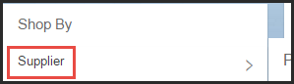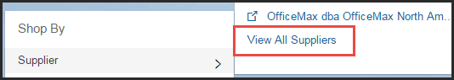
View the list of catalogs, if there is an icon to the left of the name it’s a punch-out catalog. If no icon it’s a hosted catalog.  Punch-out - user goes out to the vendor’s website to search and sees potential results. Hosted - user stays in Ariba searches and sees potentials results. | 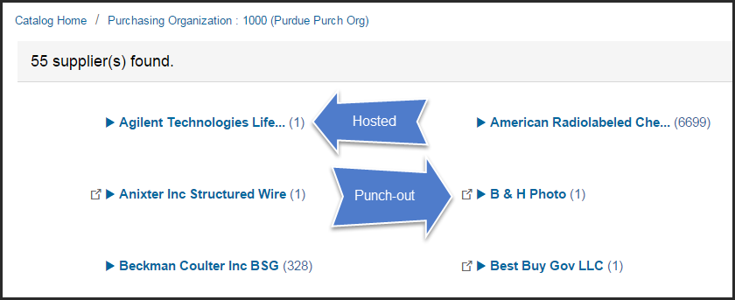
If no catalog,  From the Catalog tab, click Non-Catalog Item. | 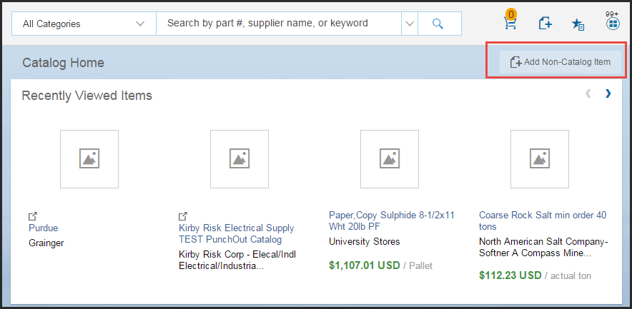
Define the Non-Catalog Item:  - Provide a full Description for the item, make sure the vendor is able to fulfill the order based on this description. Select the appropriate Commodity Code, (must use a 4, 6 or 8 digit commodity code). Requisition cannot be submitted with a two digit commodity code assigned.  - The Material Group will default based on the commodity code selected. The Account Type will automatically default to expense.  - Enter the Quantity, Unit of Measure, and Price for the item,  - Click the Update Amount button.  Enter each item as a separate line item. Unless directed to do otherwise by a staff member of Procurement Services.  TIP: If Shipping/Freight or Special Handling is expected to be $100 or more, it is recommended to add a line item to the requisition. This will assist in paying the invoice in a timely manner without manual intervention needed.  If Shipping is on a quote it should be entered as a line item on the requisition.  If the vendor requests that shipping be entered on the PO, it should be entered as a line item on the requisition. | 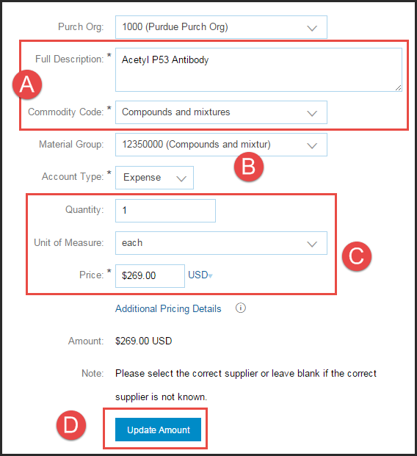
- Select the Vendor for the list,  - Provide the Supplier Part Number, if no supplier part number is known, enter "NO PN". If left blank, a Purchasing Agent is added to approval flow.  View the Searching for Supplier in Ariba P2P QRC, Searching for Vendor in SAP QRC and view the abbreviations list used for vendor names. | 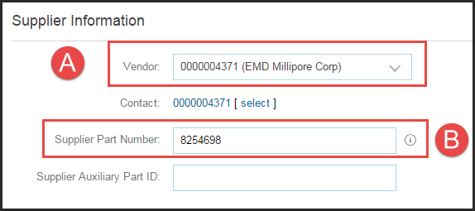
After the information has been completed, click Add to Cart.  Repeat the previous steps for each item and shipping if $100 or more. | 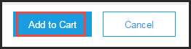
If all items have been added to the requisition, skip to the Submitting the Requisition section.
Best Practice is not to mix catalog and non-catalog line items on the same requisition.

Submitting the Requisition
Once all items are added to requisition, click the shopping cart icon.  Click Proceed to Checkout. | 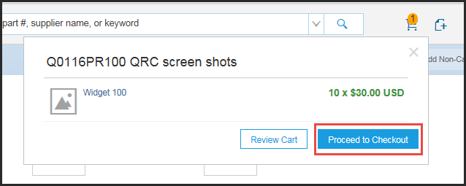
Complete requisition Summary:  - Title: follow departmental naming convention.  - Deliver To: Delivery instructions from front or back door to person within the building. Person’s name, Floor, Room #, Department name, etc.  - Need-by-Date to communicate to the supplier when items are needed. If requisition needs several approvals be mindful of the time it takes for approvals and the PO to reach the supplier. The supplier may have to expedite shipping (at Purdue’s cost) to meet the date.  - Comments are only recommended for non-catalog requisitions. For non-catalog requisitions <$3,000 make sure to list the source for the current, accurate pricing (e.g. quote number, the person’s name, email, phone or web address and the date). To make comments visible to the supplier, click the Visible to supplier on the purchase order check-box.  - Attachments may be added to the entire PR (non-catalog), by clicking Add Attachment. View  Adding/Deleting and Attachment to a requisition in Ariba QRC | 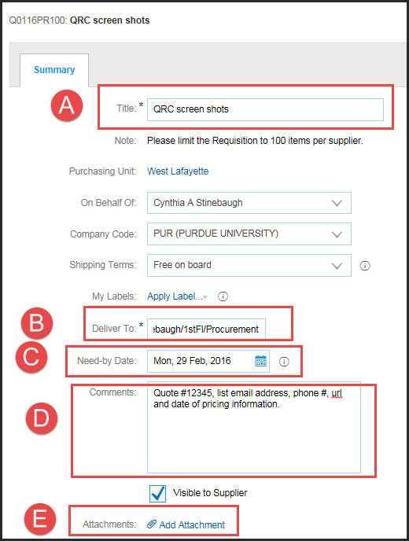
Line items may be edited, by selecting the check-box next to the item(s) and clicking Edit.  The Item Details allows for the following:  view details  - edit accounting information  - edit shipping information  - add line item comments  - add line item attachments  Note: Multiple lines items may be edited at once, by selecting the top checkbox to select all, and then clicking Edit. This is called Mass Editing. Procure-to-Pay will use the values that are selected for the first item and apply to all subsequent items. | 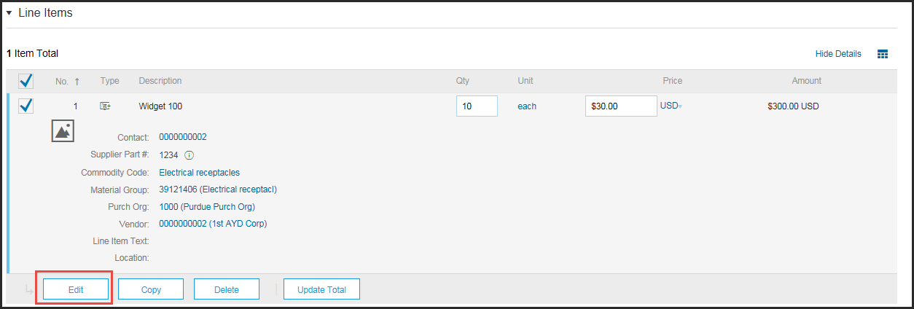  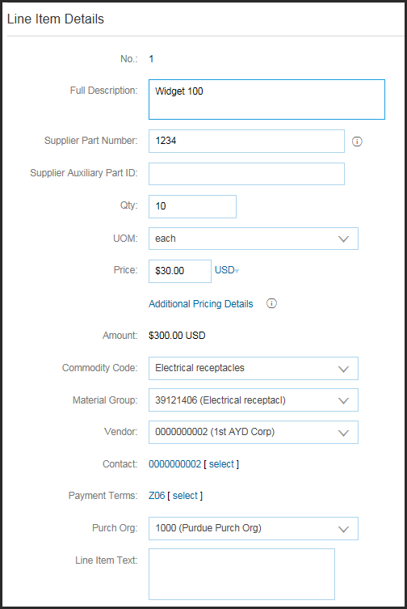
Accounting  When viewing the details of a punch-out catalog item, you will see the Edit this Punch-out catalog item link. In order to change the quantity, delete the item, or duplicate the item, you must click this link.  Account Assignment:  - Order F  - Project (WBSE) P  - Multi Account Assignment X, If Split Accounting is used and different accounts are used  For multiple accounting entries, see Split Accounting in Ariba QRC. | 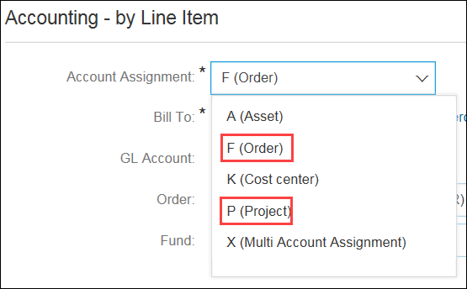  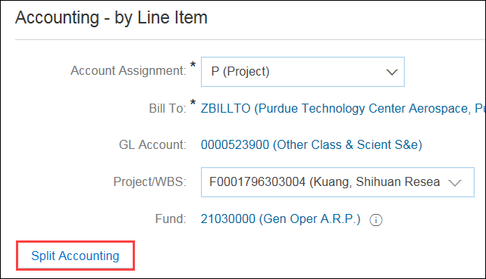
Shipping  If the Ship-To/Plant does not default from your preferences, select the appropriate location from the list.  The deliver to and need-by date will copy from the summary page. | 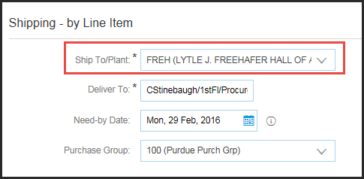
Individual Comments and Attachments can be added to each line item as necessary. These comments and attachments will be associated with the specific line item.  Click OK to return to Summary screen. | 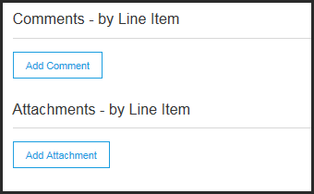
Click OK | 
Click Show Approval Flow | 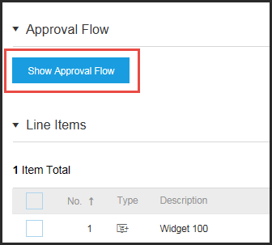
The Approval Flow section illustrates an individual or group of people who must approve the requisition before a PO is created. At least one of the people on the list must approve before the requisition can move forward.  If a group name is present, click on the name and all individual’s names in the group will display.  To add an additional approver or watcher, view the Adding/Deleting Approver or Watcher to Approval Flow in Ariba QRC. | 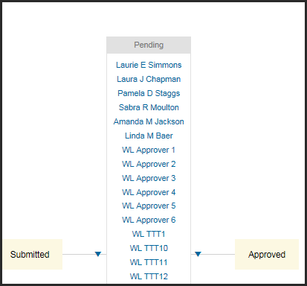
When the requisition is complete, and additional approvers have been added as needed, click Submit to submit the requisition to the indicated approvers.  Before a requisition is considered approved, one approver from each node in the approval flow must approve the requisition. If one approver denies the requisition, Procure-to-Pay will no longer send the requisition to other approvers for review and will consider the requisition as denied. The requester should review the comments or contact the approver who denied for further instructions, the requisition will showing in composing status. | 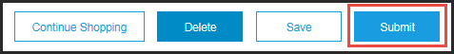
The requester can access the submitted requisition in the My Documents box on the Procurement Dashboard.  For details on monitoring the status of a requisition, view the Monitoring and Editing Requisitions QRC. | 