I suggest booking through AAA for any Purdue Employees. You may go through Concur the travel system however it would be a little more timely (in my opinion). Concur is located under myPurdue (via the travel icon below).

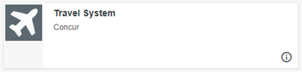

For AAA, please see contacts below. I would recommend calling someone to book your travel.

Domestic
Phone: 800-381-0971
Email: purduetravel@aca.aaa.com

International
Phone: 888-214-4340

Prior to contacting them you should complete your travel profile on concur.

Please see the directions below.
- Go to https://one.purdue.edu/
- Select Travel System
  - 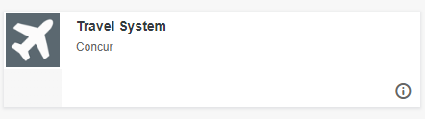
- Log in with your Boiler Key
- Then select the person icon at the top right corner.
- Go to profile settings
- Then complete your Personal Information
- Your profile would be complete after you fill in the required info

You should look up the flights you would like (departure and return) and nearby hotels (check-in and check-out date) sometimes the hotel is only reserved and then you would need to pay once you arrive (this is not always the case but this has happened), then you can call AAA and they will book this for you.
Explain to them you are a Purdue Employee and need to book travel via the ghost credit card.
Some information that you will need (if you haven’t set up your travel profile) is the account number you are using to book the travel (F. #).
Also needed would be the following.
- Name as written on the ID you present at the airport (aka driver’s license, passport, etc.)
- Date of Birth
- Employee ID
  - This can be found through https://one.purdue.edu/ go to the Employee Launchpad, select View My Profile, and find your User ID
- Phone number

If a rental car is needed, you can reserve this through AAA however, it would have to be paid for when picking up the rental with a credit card.

Meals during travel are reimbursed on a per diem basis. The amount allotted can be found using the links below.
In-side the US- https://www.gsa.gov/travel/plan-book/per-diem-rates
Outside the US- https://aoprals.state.gov/web920/per_diem.asp

