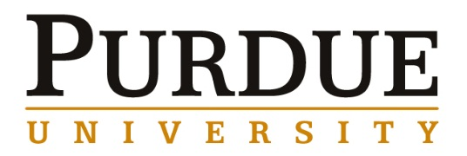
Associate Professor Luna Lu
Purdue University, Civil Engineering

Materials Engineering for Energy and Sustainability:
From Atomic-Level to Large Scale Manufacturing

Abstract

The energy crisis is one of the most significant challenges that we face in today’s society. More than 80% of the US economy relies on fossil fuels coupled with an accelerating growth of global population and greenhouse gas emissions puts our environmental sustainability under threat. To address this issue new materials and technologies for clean energy production and environmental sustainability must be developed. This presentation will cover some of my group’s recent efforts on engineering nanostructured materials for renewable energy applications, in particular high temperature thermoelectric (TE) materials and piezoelectric materials for energy conversion and power generation.

A total of 3000 trillion BTU/year of waste heat in the US could be directly converted into electricity using high temperature Thermoelectric (TE) technology. However, the impact of this technology is currently limited by the heavy use of toxic and rare materials with low operating temperatures. My group has synthesized nanostructured nitrides and oxides with tailored electrical and thermal properties by using advanced metal organic chemical vapor deposition (MOCVD) methods. The resulting thermoelectric properties are promising, including Seebeck coefficient of 710μV/K, power factor of 10.3×10-4W /mK2, and room temperature ZT of 0.23. Advanced materials characterization techniques will also be presented including high resolution X-ray diffraction (XRD), transmission electron microscope (TEM), Fourier transform infrared spectroscopy (FTIR) and photoluminescence (PL) etc. The fundamental understanding of process-structure-property relationship of nanomaterials system will be explicitly discussed with regards to their specific applications.

Biography

Na (Luna) Lu is an associate professor at the Lyles School of Civil Engineering at Purdue University. She has research interests/expertise in using nanotechnology to tailor a materials’ (electrical, thermal, mechanical, and optical) properties for renewable energy and sustainable infrastructure applications. She has authored over 60 technical publications; 4 book chapters, 1 book and 1 patent. She has given several keynote talks, multiple invited talks and numerous contributed talks at top research conferences, including Material Research Society (MRS), The Mineral, Metals and Materials (TMS) and International Conference on Composites/Nano-engineering, etc. Her research work has been featured in national and regional media, including ASCE Podcasting, Charlotte Observer, and the Charlotte Business Journal. She is the recipient of a 2014 National Science Foundation CAREER Award.
Materials Engineering
Fall 2016
MSE 690
Seminar
Series
Friday, September 16, 2016
3:30 pm Coffee
3:45 pm Seminar
ARMS 1010

