

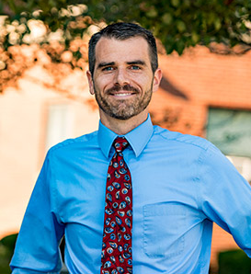

Professor Adam J. Nolte
Head and Associate Professor of Chemical Engineering,
Rose-Hulman Institute of Technology

Thin Films and Soft Materials: Responsive Materials and Material Responses

Abstract
In this broad-interest talk I will present three vignettes of materials research efforts I have led at the Rose-Hulman Institute of Technology. In the first part, I will discuss our characterization and study of hysteretic swelling in polyelectrolyte multilayer films in response to changes in environmental humidity. In the second part, I will discuss our development of a method for creating nanostructured, index-tunable antireflection coatings in a single spin-coating step through pH-induced aggregation in a silica nanoparticle precursor solution. I will conclude with some recent results stemming from our efforts with collaborators to create gelatin-based tissue phantoms for testing an embedded tumor detection technique. Specifically, I will highlight our efforts towards independent toughness and stiffness control in gelatin through sodium alginate addition. Throughout the talk, I will highlight the challenges, opportunities, and rewards involved in pursuing materials research projects at primarily undergraduate institutions like Rose-Hulman.

Biography
Dr. Adam J. Nolte is the Head and Associate Professor of Chemical Engineering at the Rose-Hulman Institute of Technology. Prior to joining Rose-Hulman, Dr. Nolte was a Materials Research Engineer in the Polymers Division at the National Institute of Standards and Technology. He holds a B.S. degree in chemical engineering from the University of Missouri-Rolla, and a Ph.D. degree in Materials Science and Engineering from MIT. Dr. Nolte’s research interests are in thin films and polymeric materials, and he enjoys advising interdisciplinary research projects with undergraduate students in these areas.

Materials Engineering
Fall 2017
MSE 690
Seminar Series
October 23, 2017

3:30 pm Coffee
3:45 pm Seminar
ARMS 1010

