

How do we make fuels using water and sunlight?

Professor Dunwei Wang

Department of Chemistry, Boston College
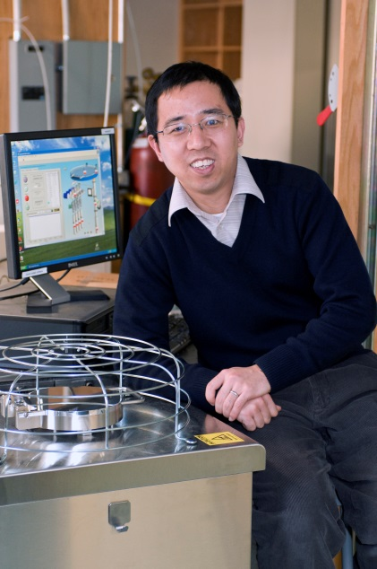
March 31, 2017

3:30 pm Coffee
3:45 pm Seminar
ARMS 1010
Materials Engineering
Spring 2017
MSE 690
Seminar
Series

Abstract
Solar energy can be directly harvested to power thermodynamically uphill reactions that produce energetic chemicals, promising a large-scale energy storage and redistribution solution. To enable these reactions, we need materials that can absorb light, separate charges, and catalyze specific chemistries. The materials should be made of earth-abundant elements to allow for large-scale implementations. They also need to be resistant against photo corrosion. To date, a low-cost, long-lasting material that can produce solar fuels with an economically meaningful efficiency remains elusive. In this talk, we present our efforts aimed at understanding what limits the development of this important field. Within the context of photoanode and photocathode, we show how the photoelectrode properties are changed by introducing material components designed for improving charge transport, surface potential accumulation, and interface kinetics, respectively. Our results highlight the importance of separately understanding thermodynamic and kinetic factors in complex systems such as that for solar fuel production. Detailed knowledge generated by our research contributes to the goal of realizing low-cost, high-efficiency artificial photosynthesis.
Biography
Dunwei Wang graduated from the University of Science and Technology of China in 2000 with a B.S. degree in chemistry. He was then trained at Stanford University (with Hongjie Dai) between 2000 and 2005, where his Ph.D. thesis was awarded the Prize for Young Chemists by the International Union of Pure and Applied Chemistry (2006). After two years of postdoctoral study with James R. Heath at Caltech, he joined the faculty of Boston College where he is currently an Associate Professor of Chemistry. His research concerns the development of new materials that can be used for efficient solar energy conversion and storage. He is a recipient of an NSF CAREER award (2011), a Sloan Research Fellowship (2012), a Massachusetts Clean Energy Center (MassCEC) Catalyst award (2011) and a Japan Society for Promotion of Science Fellowship (2016).

