
Naoki Soneda
Director, Materials Science Research Laboratory
Central Research Institute of Electric Power Industry (CRIEPI)
Japan

Characterization and modeling of damage in nuclear materials

Structural integrity of nuclear components must be guaranteed for the long-term and safe operation of nuclear power plants. Materials used in those components are used under severe conditions such as neutron irradiation and high temperatures, which cause microstructural changes in the materials, resulting in the degradation of material performance. Behavior of solute atoms is particularly important because nuclear materials are alloys with several elements, some of which form segregation and clustering that affect material performance. Thus, characterization and modeling of solute atom behavior are the keys to understand the changes in performance of nuclear materials. CRIEPI has been working on materials degradation issues together with all the Japanese electric utilities who own nuclear power plants. Over the last 10 years, we’ve focused on the application of atom probe tomography (APT) technique to the characterization of nuclear materials used in the commercial nuclear power plants. Low alloy steels used in reactor pressure vessels, austenitic stainless steels used in reactor core internals, cast stainless steels used in pipes and pumps, and zircalloys used in fuel cladding are of our primary interests.
In this talk, I will demonstrate how effectively the APT technique has been applied to these materials, and, in some cases, how the microstructural information is correlated with the materials performance. I will also briefly touch the activities in the Materials Science Research Laboratory of CRIEPI at the beginning of my talk. Our primary interests are high temperature fossile materials, batteries, SiC for power devices and organic semi-conductors using liquid ion in addition to the nuclear materials.
About the presenter
I obtained doctoral degree in nuclear engineering in 1989 from the University of Tokyo. I joined CRIEPI in 1989, and since then I have been mainly working on the structural integrity assessment of reactor pressure vessels (RPVs) of light water reactors. In 1996-1997, I spent one year in Lawrence Livermore National Laboratory under supervision of Prof. Tomas Diaz de la Rubia to work on the multiscale computer simulation of radiation damage in iron. I was an associate professor of the University of Tokyo from 2000 to 2002. In 2010 – 2014, I served as the chairman of IGRDM (International Group of Radiation Damage Mechanisms), which is an international expert group working on radiation damage in RPV steels. Currently, I am an associate vice president of CRIEPI, and the director of the materials science research laboratory of CRIEPI. “Irradiation Embrittlement of Reactor Pressure Vessels (RPVs) in Nuclear Power Plants” published from Woodhead Publishing in 2014 is my recent publication.
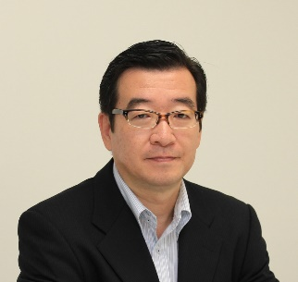

Monday, April 18, 2016
3:30 pm Coffee
3:45 pm Seminar
ARMS 1010
Materials Engineering
Spring 2016
MSE 690
Seminar
Series

