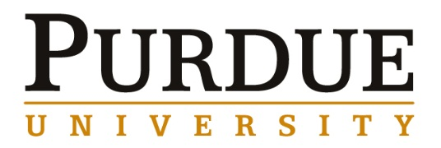

Geoff Brennecka, Assistant Professor
Department of Metallurgical and Materials Engineering and
Colorado Center for Advanced Ceramics
Colorado School of Mines, Golden, CO

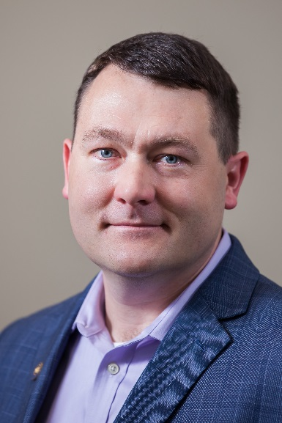

Function from frustration: Taking advantage of complexity,
heterogeneity, and nonlinearity in electrical ceramics

Abstract
One common method for improving—or at least altering—the behavior of materials and integrated materials systems is to frustrate them, for example via proximity to a phase transition or by kinetically hindering the march towards thermodynamic equilibrium. This presentation will discuss a couple of case studies that illustrate some of the challenges and opportunities associated with chemical heterogeneity in complex materials and microstructures, with a particular focus on resulting effects on electrical and electromechanical response in dielectric ceramics. In one case, we alloy AlN and ScN at compositions that would require >5000°C to be at equilibrium and manage to triple the electromechanical response in the process. In another, we take advantage of kinetic hindrance to develop and integrate high-performance heterogeneous Bi-based dielectrics with low-cost metallic Cu electrodes. Time permitting, we will also discuss how the promise of nonlinear dielectrics is currently hindered by incomplete descriptions of ferroelectric domain dynamics under large driving fields.

Biography
Geoff Brennecka received BS and MS degrees in Ceramic Engineering from the University of Missouri-Rolla (now Missouri S&T) in 2001 and 2002 and a PhD in MatSE from the University of Illinois in 2006. He spent 8 years as technical staff at Sandia National Laboratories before joining the Colorado School of Mines in 2014. Geoff currently serves on the Board of Directors for the American Ceramic Society (ACerS), as Chair of the ACerS Electronics Division, and on the Administrative Committee of the IEEE Ultrasonics, Ferroelectrics, and Frequency Control Society. Geoff is a recipient of the NSF CAREER award, Young Alumnus awards from both Missouri S&T and the University of Illinois, the IEEE Ferroelectrics Young Investigator Award, Du-Co Ceramics Young Professional Award, and Karl Schwartzwalder Professional Achievement in Ceramic Engineering award.

Materials Engineering
Fall 2016
MSE 690
Seminar
Series

Friday, November 4, 2016
3:30 pm Coffee
3:45 pm Seminar
ARMS 1010

