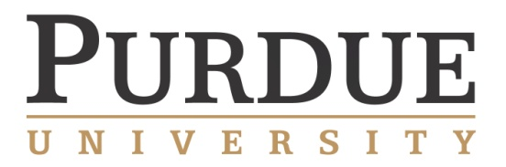

College of Engineering and College of Science
Predictive Science & Engineering Faculty Candidate

SEMIINAR
Wednesday, July 2, 2014, 10:30am, WTHR 172

Chemical Predictive Modeling in Actinide Chemistry and Catalysis

Dr. Ping Yang
W.R. Wiley Environmental Molecular Sciences Laboratory
Pacific Northwest National Laboratory
Richland, Washington, 99352
Email: ping.yang@pnnl.gov

Abstract:
Density Functional Theory-based approaches are highly successful at characterizing chemical properties, such as thermodynamics, bonding interactions, and chemical reactivity, and are a good complement to modern experimental spectroscopic techniques. In this talk, I will present recent progress in quantum chemical computations applied to heavy element chemistry and transition-metal catalysis for sustainable energy and show how the synergy between theory and experiment has greatly accelerated progress in these fields. I will first demonstrate the predictive capability of DFT for coordination modes and affinity of ligands composed of multiple competitive binding sites to actinide centers. Such ligand can help address environmental and health concerns associated with actinides. The theoretical results are validated by spectroscopic characterizations. Next, I will illustrate that the combination of electronic structure theory and NMR/EPR provides critical insights into the structure-function relationship of molecular catalytic systems. A detailed molecular-level understanding of the energetic and mechanistic factors controlling chemistry opens the door to computer-aided optimization of chelating ligands for separation sciences, molecular catalysts, and nanomaterials.

Short Bio:
Dr. Yang is a Senior Research Scientist in the Molecular Science Computing group of the Environmental Molecular Sciences Laboratory (EMSL) at Pacific Northwest National Laboratory. Her research interests lie in application-driven computational chemistry in the area of energy conversion materials and nano-materials containing heavy elements and transition metals. Prior to joining Pacific Northwest National Laboratory in 2008, Dr. Yang obtained a Ph.D. in Chemistry and an MS in Computer Science from Michigan Technological

