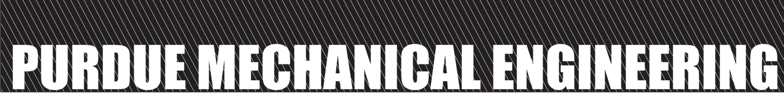
MIDWEST MECHANICS SEMINAR
Dr. Wei Cai
Department of Mechanical Engineering
Stanford University
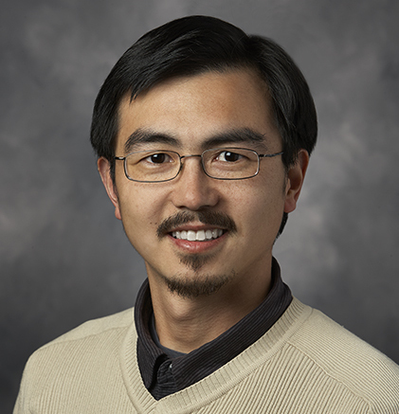
February 13, 2017
1:00pm, ME 2054

Dislocation Dynamics across Scales

Abstract:
Understanding plasticity and strength of crystalline materials in terms of the physics of microscopic defects has been a long-standing goal of materials research. In this talk, I will use three examples to illustrate dislocation processes at different length and time scales in a crystal. The bulk of the talk will be devoted to dislocation dynamics at the mesoscale and how it gives rise to the stress-strain response of the crystal. Over the last two decades, much effort has been placed on the prediction of stress-strain curve of single crystals through large-scale dislocation dynamics (DD) simulations. If successful, DD can thus provide a quantitative link, which has been lacking to date, between dislocation physics at the atomistic scale and crystal plasticity at the continuum scale. Unfortunately, the progress in this direction has been limited by the very small strain that can be routinely reached (<1%) by existing DD simulations compared with the typical strain (up to 30%) in experiments. A series of advanced time integration algorithms have been developed to expand the strain range of DD simulations. The resulting (force-based subcycling) algorithm leads to an increase of computational efficiency by more than 100 times. As a result, a systematic investigation on the relation between the unit mechanisms and work hardening rate is now possible. By changing rules on unit mechanisms in DD simulations, we determine the relative importance of different dislocation reactions on the hardening rate. We find that glissile junctions are the most important junction type for hardening, with collinear and Lomer junctions second most important. A Boltzmann-type theory based on dislocation line length distributions is constructed to explain the role of different junctions on the hardening rate revealed by DD simulations. The other two examples that I will briefly mention are: dislocation nucleation in a microfluidic crystal and dislocation mobility in a ⁴He quantum crystal. They illustrate how dislocation core structures and processes at the atomic scale influence the collective dislocation dynamics at the mesoscale.

Presenter Bio:
Wei Cai received his B.S. degree in optoelectronic engineering from Huazhong University of Science and Technology, P. R. China in 1995, and his PhD degree in nuclear engineering from Massachusetts Institute of Technology in 2001. He was a Lawrence Postdoctoral Fellow at the Lawrence Livermore National Laboratory from 2001 to 2004. He is currently an Associate Professor in the Department of Mechanical Engineering at Stanford University. He received the Presidential Early Career Award for Scientists and Engineers in 2004, and the American Society of Mechanical Engineers Hughes Young Investigator Award in 2013. His research interests include dislocation dynamics and metal plasticity, atomistic simulations of deformation, synthesis and transport mechanisms at the nanoscale. He is co-author of 95 journal publications in these and related fields, a book “Computer Simulations of Dislocations” (2006) and a undergraduate/graduate textbook, “Imperfections in Crystalline Solids” (2016).

