MSE 690 Seminar Series Fall 2025
Dr. Jian Luo
Professor of Chemical Engineering, Nano Engineering, and Materials Science Engineering.
UC San Diego
Monday, September 8th, 2025

Time | Event | Location
9:00am- 9:30am | Transportation to Armstrong Building
9:30am- 10:00am | Meeting with Prof. Haiyan Wang | ARMS 2235
10:00am- 10:30am | Meeting with Prof. Edwin Garcia | ARMS 2325
10:30am- 11:00am | Meeting with Prof. Bryan Huey, School Head of MSE | ARMS 2301
11:00am- 11:30am | Meeting with Prof. Xinghang Zhang | ARMS 2225
11:30am- 12:00pm | Meeting with Prof. Nik Chawla, Associate Dean for Research and Ransburg Professor | ARMS 2313
12:00pm- 1:30pm | Luncheon with graduate students Tyriek A Craigs, Matthew A Thompson, Yang Chen, Shiyu Zhou, Chang Liu, Danny Hermawan, Alfredo Sanjuan, | TBD
1:30pm- 2:00pm | Meeting with Prof. Michael Titus | ARMS 2309
2:00pm- 2:30pm | Meeting with Prof. Gary Cheng | ARMS 2222 (room confirmed)
2:30pm- 3:00pm | Meeting with Prof. Scott Mao | ARMS 2317
3:00pm- 3:30pm | Seminar Prep | ARMS 2303
3:30pm- 5:00pm | Seminar  Deciphering 2D Interfacial Phases: From Computing Grain Boundary Phase Diagrams to Exploring Novel Processing and Compositionally Complex Ceramics  Prof. Jian Luo (UCSD) | ARMS 1010
6:00pm-7:30PM | Dinner with Profs. Rodney Trice, Edwin Garcia, Haiyan Wang and Vikas Tomar | TBD

Thank You for your visit! Boiler UP!
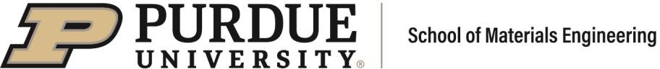
Andriana Williams, will3826@purdue.edu, or 765-494-4100
Lisa Stacey, staceyl@purdue.edu or 765-494-4095

