
Dr. Darren Mollot
Director, Exploratory Research and Innovation
Office of Fossil Energy U.S. Department of Energy

Opportunities in U.S. Energy Technology
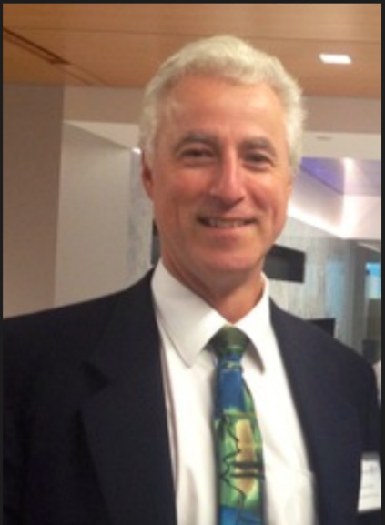

Materials Engineering
Special Guest
Speaker
Abstract
Our technology and innovation rich society is dependent on continuous access to abundant, reliable, affordable and sustainable energy. In turn, the dramatic pace of innovation and technological breakthrough is responsible for a dramatic decrease in the cost of renewable energy, an increases in recoverable natural gas, smart grids, etc., and is leading to an energy infrastructure with greater flexibility, resilience, optionality, and capability. Unfortunately, some of the same technologies have also given bad actors the tools and potential attack vectors to sabotage that very infrastructure via cyber and other means. This presentation will give some general background on the Department of Energy and its mission and then survey the infrastructure that ensures that the light switches in our homes always turn on the lights and that the hydrocarbons that fuel our vehicles, heat our homes, and support many of our industries are always there. With this as background the presentation will highlight some of the challenges our evolving energy infrastructure faces and give some historic perspective on how they may be addressed. Finally, a few leading edge energy technologies, including one based on a partnership with Purdue, will be discussed.
Biography
Dr. Darren Mollot is the Director of Exploratory Research and Innovation in the Office of Fossil Energy at the U.S. Department of Energy (DOE). In this position, Dr. Mollot advices senior management on scientific and technological breakthroughs, directs exploratory research projects designed to rapidly accelerate high risk, high programmatic impact research, and identify potential opportunities to accelerate progress toward Office objectives.
He has worked for the DOE’s Office of Fossil Energy since 1992 and has served in many roles including most recently as Associate Deputy Assistant Secretary for Clean Coal and Carbon Management in the Office of Fossil. Dr. Mollot has also served as Office Director for Advanced Fossil Technology Systems, as a Research Scientist and Project Manager at the National Energy Technology Laboratory, Technical Liaison and start-up Team Lead at the National Carbon Capture Center, as the turbines Program Manager. In 1999, Dr. Mollot was selected as a Congressional Science Fellow and served for a year under Senator Rockefeller.
Prior to joining DOE, Dr. Mollot worked in the private sector, holding positions with IBM and Westinghouse Electric Corporation. He earned his Doctor of Philosophy from the State University of New York at Buffalo in Mechanical and Aerospace Engineering.

May 29, 2019

9:30 am Coffee
10:00 am Seminar
ARMS 1010

