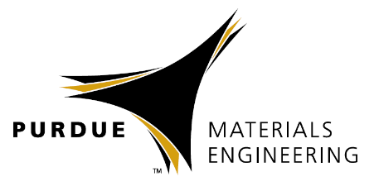
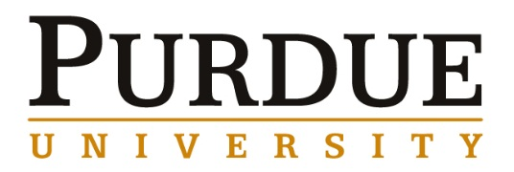



Materials Engineering
Spring 2019

MSE 690
Seminar
Series

April 26, 2019

Coffee/Snacks
3:30pm

Seminar
3:45pm

ARMS 1010

Abstract

Recent development of nickel superalloys for additive manufacturing has shown to be challenging due to the susceptibility to micro cracking in as build microstructure. Significant effort has gone into optimizing build parameters for these hard to process alloys. To reduce the parameter development cycle for challenging materials, GE Research developed and continue to enhance a framework that utilizes probabilistic machine learning (ML), intelligent sampling and optimization protocols, coupled with high-throughput printing, characterization, and in-situ monitoring systems to dramatically accelerate the developmental process. A new protocol was developed by leveraging machine learning algorithm. In this presentation, the framework along with demonstration of the use of machine learning method to guide parameter development for additive manufacturing will be given.

Biography

Voramon Dheeradhada (dheeradh@research.ge.com) is a Senior Materials Engineer in the Structural Materials discipline at GE Research. She received her M.S. and Ph.D. in Materials Science from Purdue University and was recently awarded an Outstanding Materials Engineer by Materials Science and Engineering Department, Purdue University. Her expertise is in alloy and metallic coating development with the focus on environmental degradation, and additive manufacturing of high temperature structural alloys for aerospace and power generation.

Voramon Dheeradhada, Ph.D.
GE Research

Machine learning assisted parameter development for additive manufacturing

