Chesnut Hill Colorblock Fleece Jacket (Quarter-zip)
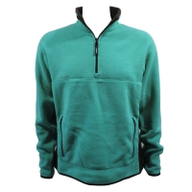
-Black with black zippers, Embroidery 3”X3” (S-XL)*
-$40 apiece
Port Authority – Ladies Silk Touch Sport Shirt
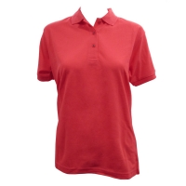
-Black, Embroidery 3”X3” (S-XL)*
-$20 apiece
Port Authority – Silk Touch Sport Shirt (Guys)
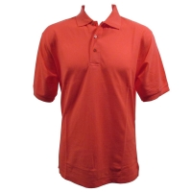
-Black, Embroidery 3”X3” (S-XL)*
-$20 apiece

*Larger sizes are available for all three items at corresponding additional cost
2XL: +$1, 3XL: +$1.50, 4XL: +$2.50
Logo
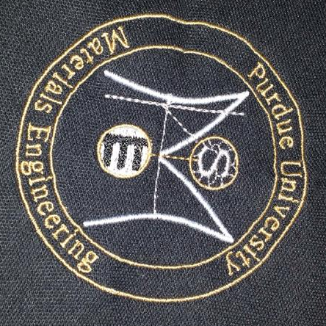

All orders should be placed by close of business on Friday, November 22nd.

