

Analytical Chemistry Seminar

Tuesday, September 28, 2021
3:30 PM, WTHR 320

“Reddish-Brown Stains: Identifying Bloodstains at a Crime Scene Using Hyperspectral Imaging”

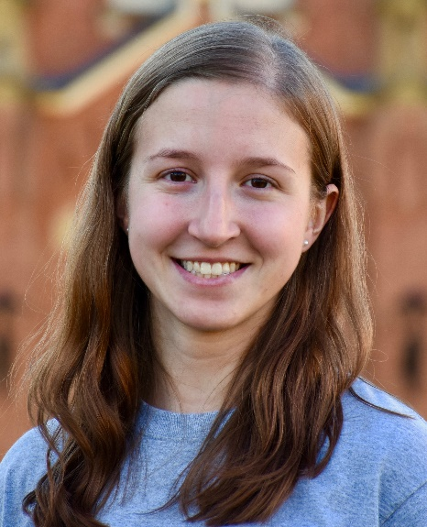d
Samantha Mehnert
Department of Chemistry, Purdue University

Abstract
At a crime scene it is important to create a timeline of the events that occurred and to locate potential sources of evidence. Bloodstains are a highly useful source of evidence because they may contain DNA information, indicate the weapon used, and potentially establish a timeline of events using the age of droplets. However, current on-scene identification of bloodstains involves techniques that are destructive and non-specific.^{1,2} The recent implementation of hyperspectral imaging (HSI) has shown promising results in the non-destructive characterization of bloodstains, as it combines spectroscopy and imaging techniques to form a hypercube containing both spectral and spatial information.^{2,3} This presentation will introduce how HSI can discriminate bloodstains from similarly colored substances¹ and dark backgrounds,⁴ but will focus on how the various heme compounds resulting from the degradation of blood can be visualized and used to construct a timeline of the crime scene.^{3,5}

References
(1) Zulfiqar, M.; Ahmad, M.; Sohaib, A.; Mazzara, M.; Distefano, S. Hyperspectral Imaging for Bloodstain Identification. Sensors 2021, 21 (9), 1–20. https://doi.org/10.3390/s21093045.
(2) Edelman, G. J.; Gaston, E.; van Leeuwen, T. G.; Cullen, P. J.; Aalders, M. C. G. Hyperspectral Imaging for Non-Contact Analysis of Forensic Traces. Forensic Sci. Int. 2012, 223 (1–3), 28–39. https://doi.org/10.1016/j.forsciint.2012.09.012.
(3) Majda, A.; Wietecha-Posłuszny, R.; Mendys, A.; Wójtowicz, A.; Łydżba-Kopczyńska, B. Hyperspectral Imaging and Multivariate Analysis in the Dried Blood Spots Investigations. Appl. Phys. A Mater. Sci. Process. 2018, 124 (4), 1–8. https://doi.org/10.1007/s00339-018-1739-6.
(4) Edelman, G. J.; Leeuwen, T. G.; Aalders, M. C. Visualization of Latent Blood Stains Using Visible Reflectance Hyperspectral Imaging and Chemometrics. J Forensic Sci. 2015, 60 (s1), S188–S192. https://doi.org/10.1111/1556-4029.12591.
(5) Weber, A. R.; Lednev, I. K. Crime Clock – Analytical Studies for Approximating Time since Deposition of Bloodstains. Forensic Chem. 2020, 19 (May), 100248. https://doi.org/10.1016/j.forc.2020.100248.

Seminar Time shared with Saniya Virani

