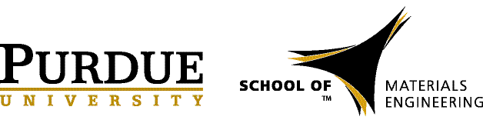

Jacob Jones
Professor, Department of Materials Science and Engineering
Director, Analytical Instrumentation Facility
North Carolina State University

MSE 690 Guest Speaker

September 24- 25, 2015

Time | Event | Location | Notes
4:01 pm | Arrive at Indianapolis Airport (ETA 4:01pm) |  | Confirmation: Delta HU6J7B
 | Check-in at the Hilton Garden Inn | Wabash Landing
6:30 pm | Dinner with Professor Elliott Slamovich | Dinner with Professor Elliott Slamovich | Prof. Slamovich will pick up at Hilton  Bistro or Mcgraws

Friday, September 25, 2015

Time | Event | Location | Notes
8:00 - 9:00 am | Breakfast with Materials Engineering Professor and Department Head, David Bahr and Professor Rodney Trice | Meet Prof. Bahr at Broken Egg | Prof. Trice will pick up from hotel and Meet Prof. Bahr at Broken Egg
9:30 - 11:30 am | Tour of Birck, Bindley and Discovery Park | BIRCK | Trice or Bahr will drop off at Birck
11:30 - 12:45 pm | Lunch w/ MSE Grad Students: Jana Anirruddha, John Rotella and Logan Kearney | TBD | Jana will pick Jacob up Birck for lunch
1:00 - 1:30 pm | Meet with Professor Ken Sandhage | WANG 4514
1:45 - 2:15 pm | Meet with Professor Shriram Ramanathan | ARMS 2309
2:30 - 3:00 pm | Tour of Armstrong | Meet in ARMS 2300
3:15 - 3:30 pm | Prep for Seminar | ARMS 1109
3:30 - 5:00 pm | Seminar | ARMS 1109
5:30 pm | Alumni Tent Event

