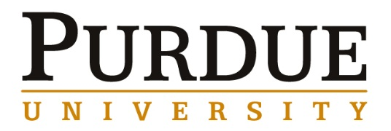
College of Engineering
Energetics Searches Faculty Candidate

Dr. Rajen B. Patel
US Army, ARDEC

"Amorphous Energetics”

Abstract
To date, the use of high explosives (HEs) has been largely limited to their crystalline forms. The glassy forms of these materials have not received much attention, for reasons including difficulty of production and stabilization. While the highest density and stability of HEs is only attainable in the crystalline state, the unique properties exhibited by glasses may offer significant practical advantages. In this seminar, the production and properties of glassy molecular dispersions based on CL-20, HMX, and polyvinyl acetate will be discussed. The glassy form was achieved by rapid precipitation of the composite ingredients using spray drying. The role of the additives on glass formation was examined. Characterization revealed multiple novel properties in comparison to the traditional crystalline HE-based compositions, such as higher configuration enthalpy and a glass transition temperature. In addition to the aforementioned properties, glassy energetics have also been found to be optically transparent, which could prove advantageous for certain laser based fuzing applications. Most excitingly, glassy energetics seem to be a pathway to ‘on-demand’ sensitization. In the amorphous form, defects such as grain boundaries and porosity can be eliminated. This results in a highly insensitive, difficult to initiate energetic. However, after thermally induced crystallization, the explosive becomes much more shock sensitive. These findings serve to highlight the unique opportunity presented by glassy energetics to achieve improvements beyond those attainable with traditional crystalline materials.
About the presenter
Dr. Rajen Patel has been researching energetic materials for over 13 years. He initially experimented with nanothermites, but primarily has worked on novel solid phases of organic explosives. He has helped to pioneer new methods of producing organic nanoenergetic formulations. He demonstrated that these types of materials have improved sensitivity and mechanical properties in comparison to legacy explosives. Recently, he has started working on bulk amorphous nitramine formulations, producing the seminal work in that field. Dr. Patel was the first researcher to demonstrate the feasibility of on demand sensitization of energetics in bulk applications. In addition to novel solid phases of energetics, he is also interested in improvements in the manufacturing of energetic materials through the use of probe technology based on ultrasound, UV-VIS, and Raman spectroscopy. Beyond energetics, Dr. Patel has worked on nanotube composites and has developed scalable methods of manufacturing them. He has also discovered new types of nanomaterials, such as boron hybrid carbon nanotubes, which offer a number of advantages in comparison to traditional nanotubes. His doctoral work was on boron based nanomaterials, where he introduced a number of novel nanostructures.

Energetics Searches Faculty Candidate

Materials Engineering Faculty Candidate

June 6, 2016
3:30pm Seminar
ARMS 1103

