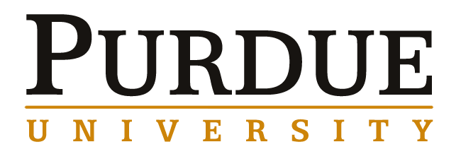

MECHANICAL ENGINEERING SEMINAR

May 3rd, 2017 9:30am Room ME 2054

Dr. Darren Hartl

Research Assistant Professor of Aerospace Engineering at Texas A&M University
Liquid Metals, Genetic Programming and Morphing Wings: From Academia to AFRL and Back Again
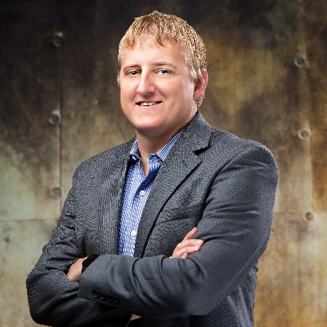
“The development of active and adaptive aero structures based on the behavior of unique materials is certainly nothing new, having been considered with great fervor especially since the various federally funded efforts of the 1990's. What is new and highly enabling is the increased fidelity of three-dimensional modeling tools and especially the implementation of these tools into ever more comprehensive design frameworks. Given the sustained improvement of such tools, full analysis-driven optimization considering such concepts as coupled fields and uncertainty may soon become common practice in the multifunctional aero structure design community. This will enable both the increased performance of current concepts and an expansion in creativity regarding the kinds of material and structural configurations considered. This talk will review the two major Air Force Research Laboratory efforts with which Dr. Hartl has been involved over the last three years as well as his current research efforts at Texas A&M. Some of the advances in multifunctional aero structural modeling and design will be highlighted. Design concepts such as liquid metal-based reconfigurable antennas and morphing components will be described, and design approaches leveraging evolutionary genetic programming will be shared. The transition of approaches and solutions from the academic realm to the national laboratory environment and vice versa comprise a particularly unique component of Dr. Hartl’s career to date and will be addressed in detail."

Biography:

Darren J. Hartl (Ph.D. 2009, Texas A&M Aerospace Engineering) is an Assistant Professor position at Texas A&M. His work bridges the topics of advanced multifunctional material systems and their integration into aerospace platforms. Before his return to academia, Dr. Hartl held joint appointments at the Air Force Research Laboratory (AFRL) in the Materials and Manufacturing Directorate and Aerospace Systems Directorate. Dr. Hartl has over 15 years of experience working with shape memory alloys and morphing structures and has co-authored 133 technical publications on the topics of active materials modeling, testing, and integration into morphing structures. He serves as an Associate Editor for the Journal of Intelligent Material Systems and Structures and was recently selected as the 2016 recipient of the ASME Gary Anderson Early Achievement Award."

If you would like to meet with Dr. Hartl on May 2nd ,2017 please contact Elisha Carpenter, carpen72@purdue.edu or Ph. 765 496-7553 to see if we can accommodate your request within his schedule.

