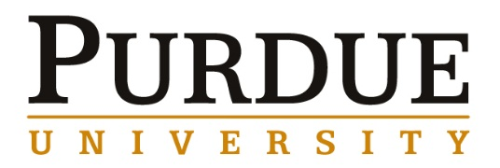

Jason Shian-Ching Jang
Distinguished Professor
National Central University, Taoyuan 32001, Taiwan

Development of Bulk Metallic Glasses and Metallic Glass Thin Film Coatings for Biomedical Applications

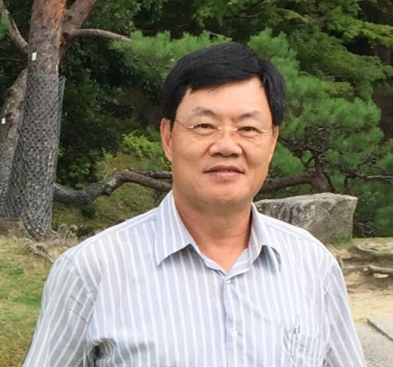
Materials Engineering
Fall 2016
MSE 690
Seminar
Series
Monday,
October 31, 2016
3:30 pm Coffee
3:45 pm Seminar
ARMS 1010

Abstract

A series of Zr-based, CuZr-based, Mg-based, Ti-based, and Fe-based bulk metallic glasses (BMGs) with good glass forming ability and bulk metallic glass composites (BMGCs, with high plasticity and toughness) have been successfully developed in the High Performance Alloy Laboratory, Institute of Materials Science and Engineering, National Central University. In addition, these BMGs and BMGCs also have been developed to apply on the medical tools and devices, including the surgical blade, dermatome, orthopedic drill, anti-bacterial coating, and porous implant. Since these BMGs and BMGCs possess high strength, high hardness, large elastic limit, excellent corrosion resistance, and superplastic forming ability. Therefore, these BMGs and BMGCs present much better performance than the commercial martensitic stainless steel and are believed to be a promising material for medical applications.
Biography

Dr. Jason Shian-Ching Jang is a distinguished professor of the Institute of Science and Engineering, National Central University, Taiwan. He received his PhD in Materials Science from North Carolina State University in Raleigh, NC, in Dec, 1989. Prior to joining Materials Research Laboratories, Industrial Technology Research Institute in Taiwan, he was a research scientist and manager at the Laboratory of Solidification and Casting in Materials Research Laboratories. He also worked as a professor and department chairman at the Department of Materials Science and Engineering, I-Shou University, Kaohsiung within 1996-2009. In 2009, he joined into the Institute of Materials Science and Engineering, National Central University, Taoyuan as a professor and chairman. He was awarded the distinguished professor in 2012 and 2015, respectively from National Central University. He is also the current director of Precision Instrument Utilization Center, National Central University. He has published more than 200 papers in journals such as Acta Mater., Applied Physics Letter, J. of Alloys and Compounds, and many more. In addition, he possesses 16 discovery patents in Taiwan and in the USA. He is also on the Editorial Board for Materials Letters.

