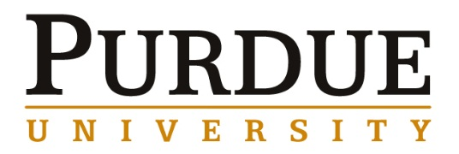

Professor Alex King
Director, Critical Materials Institute and
Professor, Materials Science and Engineering
Iowa State University

MSE 390 Guest Speaker

Wednesday, December 2, 2015
Time | Event | Location | Notes
9:30 – 10:00 am | Meet with Materials Engineering Professor Lia Stanciu | ARMS 2119
10:15 – 10:45 am | Professor Weinong Wayne Chen, Reilly Professor of Aeronautics, Astronautics and Materials Engineering  Associate Head of Aeronautics and Astronautics | ARMS 2119
10:45 –11:15 am | Meet with Materials Engineering Professor Carol Handwerker and Fu Zhao | ARMS 2326
11:15 – 11:45 am | Meet with Materials Engineering Professor Edwin Garcia | ARMS 2326
12:00 – 1:00 pm | Lunch with Materials Engineering Graduate Students: Kate Reeve, Lisa Rueschhoff, and Anneliese Brenner | TBD
1:15 – 1:45 pm | Meet with Materials Engineering Professor Rodney Trice and Kevin Trumble | ARMS 2007
1:45 – 2:15 pm | Meet with Materials Engineering Professor Ernesto Marinero | ARMS 2007
2:30 – 3:00 pm | Meet with Materials Engineering Professors Mysore Dayananda and Jeffrey Youngblood | ARMS 2007
3:15 – 3:30 pm | Prep for Seminar
3:30 – 4:20 pm | Seminar | ARMS 1010
4:30

