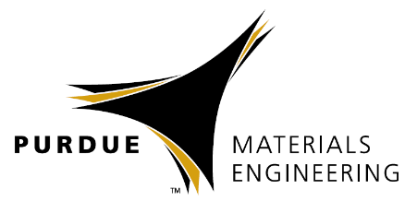


Alexandra Boltasseva
School of Electrical & Computer Engineering and Birck Nanotechnology Center, Purdue University, West Lafayette, IN 47907, USA

Emerging Materials for Nanophotonics and Plasmonics

Materials Engineering
Spring 2018

MSE 690
Seminar
Series

October 5,
2018

3:45 pm Seminar
ARMS


Abstract
The fields of nanophotonics and plasmonics have taught us unprecedented ways to control the flow light at the nanometer scale, unfolding new optical phenomena and redefining centuries-old optical elements. As we continue to transfer the recent advances into applications, the development of new material platforms has become one of the centerpieces in the field of nanophotonics. In this presentation, I will discuss emerging material platforms including transparent conducting oxides, transition metal nitrides, oxides and carbides as well as two- and quasi-two-dimensional materials for future practical optical components across the fields of on-chip optics and optoelectronics, sensing, spectroscopy and energy conversion.

Biography
Alexandra Boltasseva is a Professor at the School of Electrical & Computer Engineering and Birck Nanotechnology Center, Purdue University. She received her PhD in electrical engineering at Technical University of Denmark, DTU in 2004. Boltasseva specializes in nanophotonics, nanofabrication, optical materials, plasmonics and metamaterials. She is 2018 Blavatnik National Award for Young Scientist Finalist, and received the 2013 IEEE Photonics Society Young Investigator Award, 2013 Materials Research Society (MRS) Outstanding Young Investigator Award, the MIT Technology Review Top Young Innovator (TR35) award that "honors 35 innovators under 35 each year whose work promises to change the world", the Purdue College of Engineering Early Career Research Award, the Young Researcher Award in Advanced Optical Technologies from the University of Erlangen-Nuremberg, Germany, and the Young Elite-Researcher Award from the Danish Council for Independent Research. She is a Fellow of the Optical Society of America (OSA) and SPIE. Alexandra authored more than 130 journal articles with a total number of citations above 11000. She served on MRS Board of Directors and is Editor-in-Chief for OSA’s Optical Materials Express.

