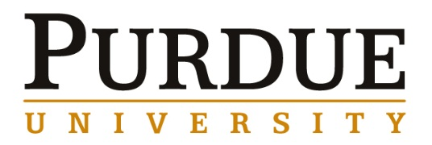
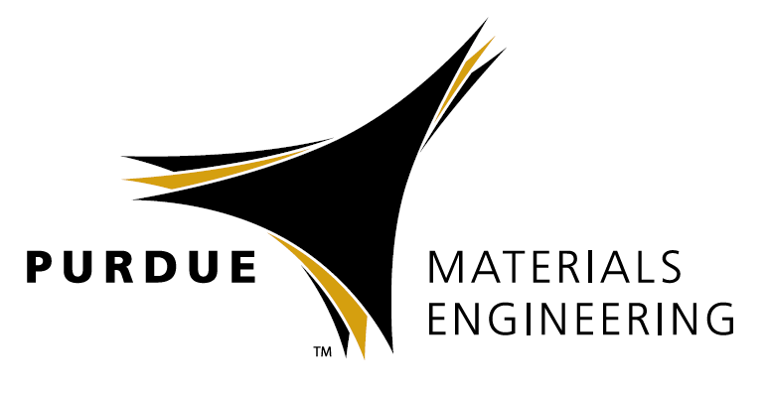
Glenn S. Daehn, Ph.D.
Mars G. Fontana Professor of Metallurgical Engineering,
Department of Materials Science and Engineering
The Ohio State University

Impulse Manufacturing: Why and How
(and how and why to support process innovation)

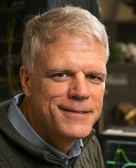
Materials Engineering
Fall 2018

MSE 690
Seminar
Series

Monday,
November 19, 2018

3:30 pm Coffee/Snacks
3:45 Seminar
ARMS 1010

Abstract
Metal forming has traditionally been carried out with very large tools on even larger presses that move slowly, so that metal that being shaped is nearly in static equilibrium. There are a number of old and emerging methods that use very short-duration impulses to form metal. Short times and high speeds can enable new and useful behaviors from the metal while being worked: formability can be improved, adiabatic shearing can facilitate cutting shapes, high speed collision can produce solid state welds and residual stresses can be locked in to produce very strong mechanical joints. The use of explosives and electromagnetic induction and repulsion (electromagnetic forming) have been widely published since the 1960’s. This presentation will focus on two new methods that generate an expanding hot gas/plasma using laser ablation and the vaporization of a rapidly joule heated metal foil. These methods can generate enormous local pressure that can be used for forming, cutting and solid-state welding. Easily-accessible solid-state impact welding processes can broadly change how advanced structures are designed and joined.
This presentation will detail our understanding of the science and phenomenology of these techniques, describe appropriate diagnostic methods, show demonstrations of practical problems that can be solved with these methods, focusing on examples and simulation of impact welding, and include with a discussion of commercialization status and challenges.
Lastly, with additional examples, the case will be made that process innovation has been essential in improving the human condition, but not well supported by the current types or scale of science and technology investments.

Biography
Glenn Daehn is the Mars G. Fontana Professor of Metallurgical Engineering at The Ohio State University. His central interests are in development of technologies and workforce needed for cleaner and more agile manufacturing. His group is currently focused on the development of impulse manufacturing technologies and Daehn has broad interests in manufacturing technology and policy issues. At Ohio State he had key roles in founding the Ohio Manufacturing Institute (omi.osu.edu), the Center for Design and Manufacturing Excellence (cdme.osu.edu) and led OSU’s engagement in Manufacturing USA Lightweight Innovations for Tomorrow (LIFT) Institute and is on the Leadership Council of MForesight, which provides manufacturing technical and policy leadership, and is the Chair of the ASM Materials Education Foundation. His academic training is in Materials Science and Engineering (B.S. from Northwestern University and M.S. and Ph.D from Stanford University).

