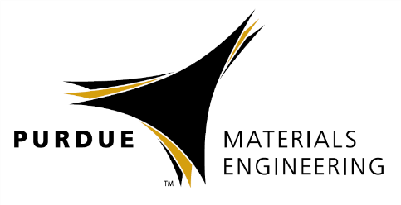

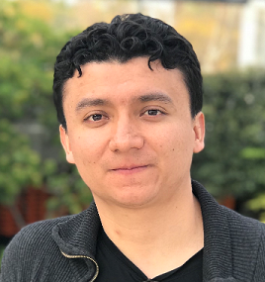

Jairo A. Diaz, Ph.D.

Center for Soft Matter Research,

New York University

DNA Patches via Fluid Solid Transition

Abstract

DNA is an exceptional tool to direct self-assembly in colloids. Nevertheless, making complex or even functional arbitrary colloidal assemblies is still quite challenging. I will present a novel route to create solid colloids with DNA patches holding different sequences that can expand the number of realizable self-assembled structures. Patch symmetries and DNA types are sorted in the liquid phase, while controlled transition to the solid phase freezes-in DNA designs for further assembly. High surface diffusion of DNA strands during fluid assembly produces stable patchy particles with desired symmetries in the order minutes. The resultant high density of DNA strands within patches can drive the assembly over densely DNA coated particles. New multi-DNA patchy particles hold promise to access metastable regions in phase diagrams and unique opportunities for complex self-assembly.
Biography

Jairo is a postdoctoral research associate at the Center for Soft Matter Research (CSMR) at New York University. He holds a PhD from Purdue MSE and a B.Sc. in Chemical Engineering from the National University of Colombia. He is a Junior Fellow of the Simons Society of Fellows.

Materials Engineering
Special Guest
Speaker

Friday, July 13th, 2018

10:30 am Coffee
11:00 am Seminar
ARMS 1021

