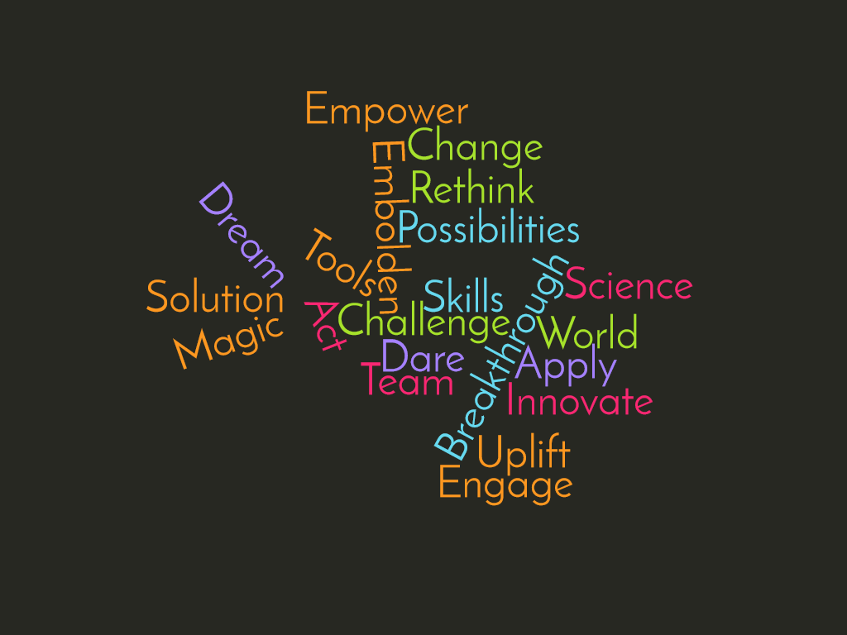
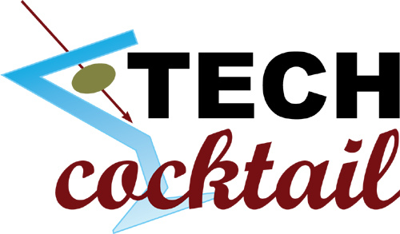
Please join an I²D Lab happy hour discussion to identify Purdue Engineering’s water-energy-food nexus innovation pipeline (i.e., what are faculty doing in this space?)
Friday, Sept. 16th @5:30 PM @ Stacked Pickle

Appetizers provided courtesy of the I²D Lab

