President:
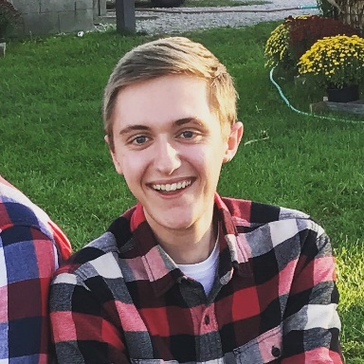
Shawn Makulec
I'm a Junior in IE, and I've been a member of EWB since my first semester at Purdue. During that time, I served for a semester as a design lead for the EPICS team, two semesters as Vice-President of Chapter Affairs, and most recently a semester as President. I traveled with the team on the implementation trip to Nakyenyi last summer, and I’m on the travel team for the Bolivia assessment trip. As President this past semester I’ve been head of the leadership design team and run our chapter meetings. I’m truly passionate about EWB, and I’m excited about the prospect of leading our chapter again next semester!

Project Manager:
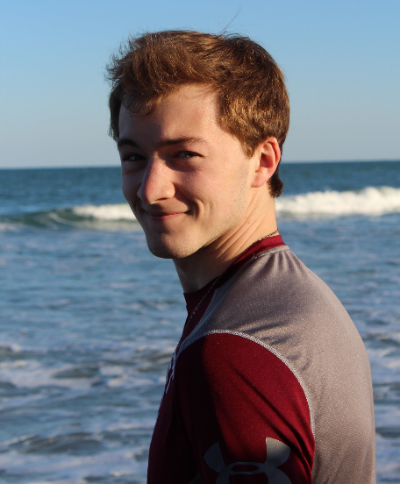
Paul Fuchs
My name is Paul Fuchs and I am a Sophomore in Aerospace Engineering. I have devoted time and energy to EWB for three semesters now, first as a part of the Future Directions and Project Selection teams responsible for picking a new project, and this semester as the Project Manager for EWB and for the first Assessment Trip to Bolivia. This water project in Bolivia has become my passion and I want to continue serving as Project Manager to make sure it is completed. With the amount of experience and involvement I have had with EWB, I am confident that I fill the role perfectly next semester.
Treasurer:
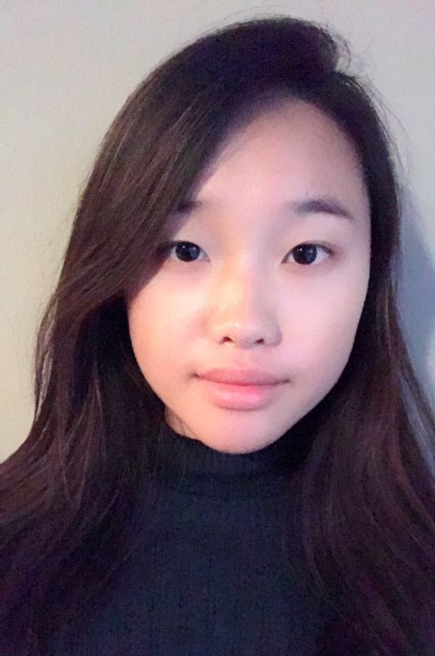
Cindy Jiang
My name is Cindy Jiang and I'm running for Treasurer. I believe that I'm the best candidate for this position because of the experience I've gained from being a grant writer. Over the course of this semester, I've worked extensively alongside the current treasurer in our efforts of obtaining more funds for EWB's projects. With each new grant, I've gained a deeper understanding of the managing and administering of this program's financial assets. I believe that with my prior background as a grant writer, I will be able to more closely bridge the efforts of the leadership team with that of the design teams I've written grants and acquired funds for. I care deeply about EWB's efforts. Our work in international development is astounding and I want to have a more crucial element in its development and success. I would be thrilled if you would consider me for this position.

Vice-President:
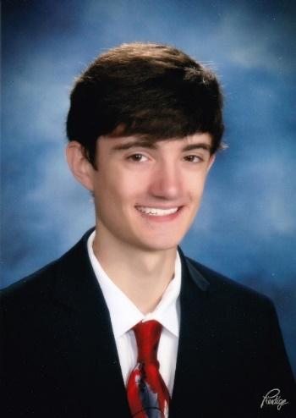
Sean Berry
My name is Sean Berry and will be a junior studying Mechanical Engineering Technology. I joined Engineers Without Borders because I believe in the philosophy and vision of the club, and I’m very motivated to play a role through the Vice President position. I believe that my technology, project management and communication skills make me a great candidate, and I would be very excited if selected to fulfill the responsibilities of the role.

Grants Head:
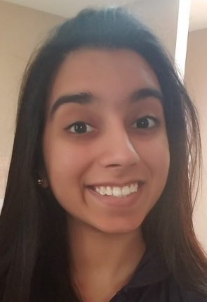
Samyu Trikkur
Hi, everyone! My name is Samyukta Trikkur. I’m a returning member of EWB, and the opportunity for Cultural Immersion through EWB really fascinates me. In the past, I have served as an ESL teacher for Spanish-speaking immigrants. I felt that the cultural knowledge I gained from them was much more impactful than the English I could impart on them. I understand the importance of experiences such as these, and I know that opportunities for cultural immersion in EWB can only be opened and facilitated through an increase in funding and grant collection. This past semester, I have worked with Margaret Levell and Cindy Jiang extensively on grants work, garnering knowledge on the grant writing process. Further, I have interacted with advisors throughout the semester—through this I’ve gained the toolkit necessary to perform proper grant review. I feel that these experiences have given me the skill-set necessary to be our chapter’s next grants head, and I would love to have another opportunity to be heavily involved with grants work!

Events/Fundraising:
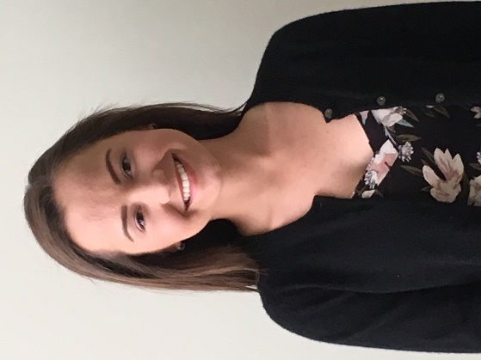
Amanda Lefebvre
I really appreciate the nomination to be the head of events/fundraising. Throughout the Fall 2017 and Spring 2018 semesters I have worked closely with the current fundraising head, Hannah Fowler, on the various fundraising events she had planned. I have already taken over as the organizer of the 5K during the Fall 2018 semester by submitting event request documents that are currently under review. I know that as the events/fundraising head it is my responsibility to organize fundraising events, be in charge of callouts/outreach, and organize social events for Engineers Without Borders. I think that getting experience with these events this semester will make me very prepared to take on the rest of the position responsibilities in the fall.

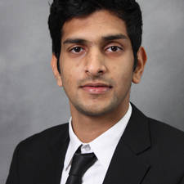
Abde Dhariwala
Hello, my name is Abdemanaf Dhariwala. I am currently on a study abroad program in Colombia. I have been a part of EWB-Purdue since the Fall of 2015. I have been on the executive board of the chapter as the Treasurer for a year and a half. Now, I would like to serve this chapter through a different officer position. Raising funds for our projects and creating awareness about our club is of paramount importance. This is something I understand completely, having overseen the finances of the club during my time as the treasurer. My goals as being the events head would be to continue working on any ongoing preparations for a large fundraiser, but also introduce new fundraising techniques that will allow the club to have a more prominent presence on campus. I am excited about this position and to be back on campus to work with EWB.

Media:
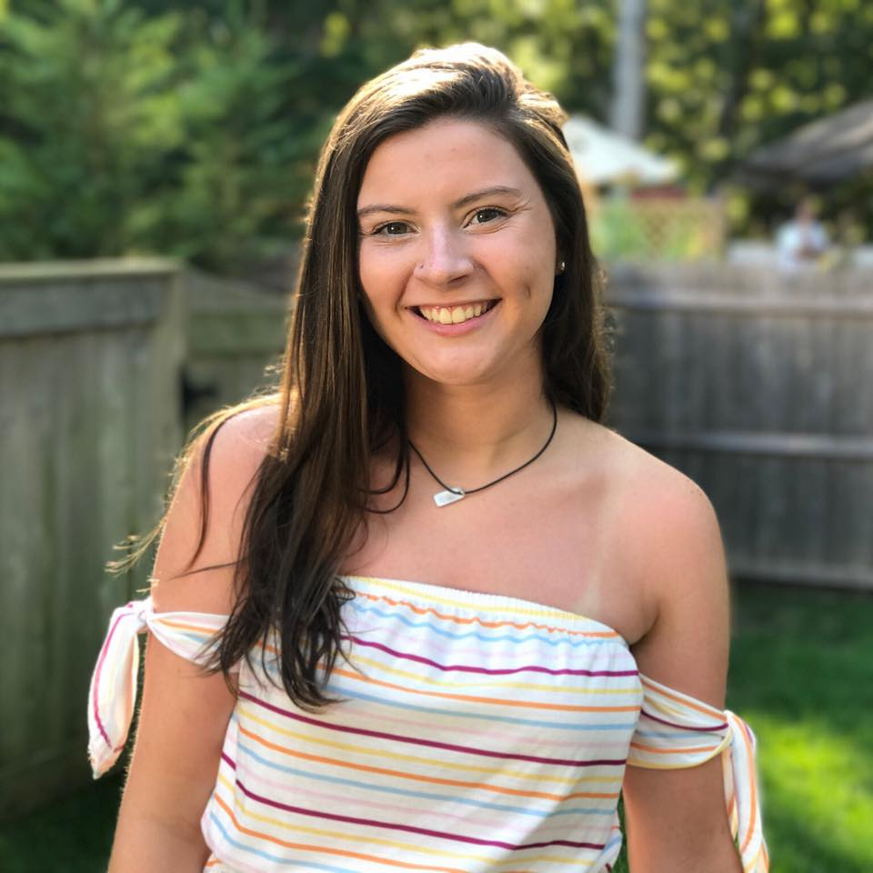
Anna Rausch
I love EWB and all that we would do and would love to serve on the leadership team as the media head. Next semester will be my second semester on the EPICS team for EWB, but my 3rd semester involved in EWB. Currently I am a freshmen but I plan on majoring in Chemical Engineering. I think I am best for the position because I have a lot of experience creating and managing websites, during high school I got my Adobe Certified in HTML and CSS and I made many websites from scratch as well as learned to update and maintain those websites. I am also very hardworking and I would make sure that all our social media was being regularly posted on with high quality content as well as keeping our website up to date with all of the new and exciting things we do over the semester. I really hope that I can help out EWB by serving as the media head next semester!
Biogas Design Lead:
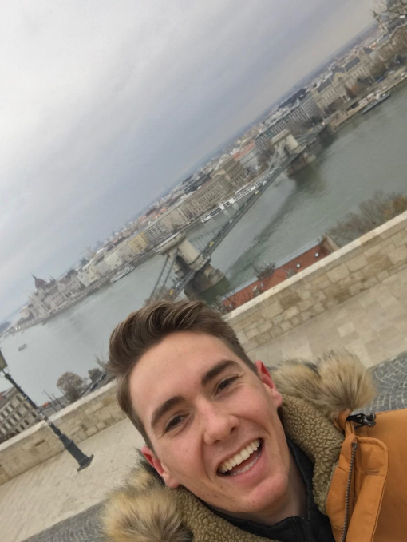
Doug Partridge
I have been the biogas lead for the Spring 2018 semester, and traveled to Uganda last summer on the assessment trip. As biogas design lead this semester we made great progress with communication to our community partners and I look forward to a critical monitoring trip.

New Member Design Lead:
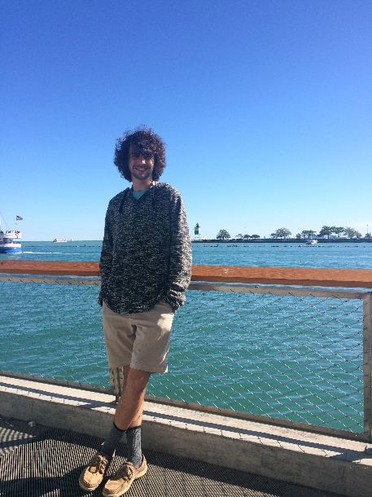
Garrett Fehrman
I believe I am an exceptional candidate for the New Member Design Lead role for next semester. This semester, I enjoyed being a member of the New Member Design Team, and would want to make the experience enjoyable for all new members. Being involved this semester, I will be familiar with the current protocols. I would welcome and help create positive change for the role next semester, and improve New Member Team attendance. I believe attendance and member interest will be the most important aspects of change for next semester, as the team appeared to shrink in size almost every week. I would be able to manage my time next fall, just as I do this semester, working, maintaining good grades, and being apart of EWB. I tend to enjoy being busy, and have a fairly flexible work schedule. I am responsible and hold my work to high expectations. Thanks again for the nomination, and I look forward to EWB next semester.

Bolivia Technical Design Lead:
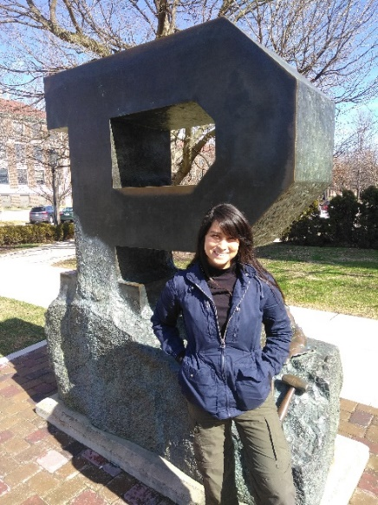
Magaly Mendoza
Because I am majoring in Environmental and Ecological Engineering, I feel particularly connected to our current water distribution project. Last semester I was part of the Project Selection team where we selected to work with Colquechata, Bolivia, this semester I am part of the Bolivia Technical team, and as part of the travel team, I am responsible for all water data collection. My experiences have enabled me to closely follow our current water distribution project as well as, learn from current and previous design leads so feel equipped to contribute as design lead next semester. I am motivated by development work and believe the work we are doing will be the foundation for my career in Environmental and Ecological Engineering.

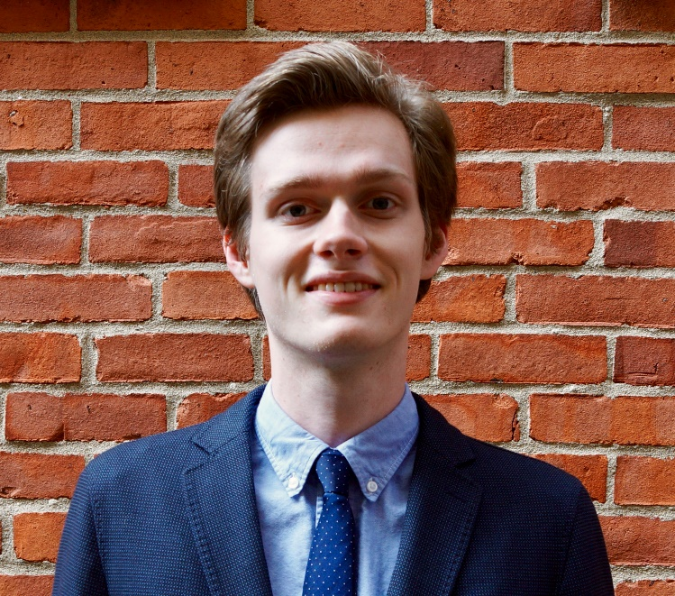
Ed Hutchinson
I believe I am the best candidate for this role because when fall semester comes around, I’ll have more than enough knowledge and experience of this project to hit the ground running. For starters, I was a member of the Bolivia Technical Team this semester, and I was in charge of researching the topography of the area and making sure the assessment trip in May is as successful as possible. Beyond that, I myself am a member of the travel team. By the time we continue the project next semester, I’ll know this project inside and out. I’ll be able to say I’ve spoken to the families and leaders of Colquechata, and that I actually trekked and surveyed the data we’ll be processing for our designs. I’ll have seen the water source in-person, met with the clients, learned exactly what they want us to help them with, and assessed the environment we plan to work with over the next five years. The technical team needs someone who will use their knowledge of the community to steer the project in the right direction. Beyond that, my experience here in EWB has been that of a leader. For the past couple of weeks, I’ve been contacting outside professors and students to organize surveying lessons for the travel team. I do this because I want this trip to be a success. I want the technical team to be prepared so that it can be as productive as possible, and I know it’ll take hard work and commitment to make that happen. This project means the world to me, and I would very much like to take charge of the technical side so that this water project makes the community of Colquechata as great as it can be.

Bolivia Cultural Design Lead:
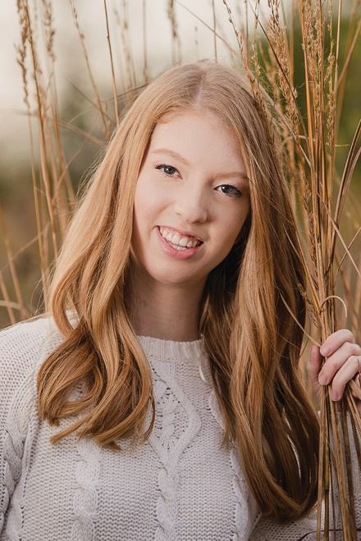
Andrea Pegg
I believe that I am a good candidate for the position for the Design Lead position for the Bolivia Cultural and Education team for three reasons. The first is that I have been a member of this team for the past semester, so I am familiar with what this group has accomplished, and what its goals are for the future. Secondly, believe that I have the organizational skills required to fulfill a design lead position, and I am ready to take on this new responsibility. Lastly, I am committed to the success of this team and to EWB as a whole. I have had so much fun working on this project this semester, and I’m ready to continue working hard this summer on the assessment trip, and throughout the next year!

