An excerpt from…
The 522 Forms for EWB-Purdue’s 2014 Assessment Trip!

While on our trip, our team took an extensive amount of photographs to remember our days and be able to explain our trip and findings to our team back at Purdue. Below are a few photographs relating to the project development on our assessment trip.

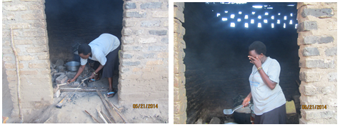
Above are pictures of Rita, the teacher of Catering at the vocation school, cooking a meal on the typical three-stone firewood stoves. Aside from the large amount of firewood used, this type of cooking creates lots of smoke, often bothering the eyes of the cooks.

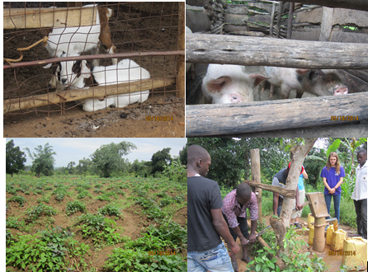
Above are a few pictures of the school grounds, including some animals, land (potato patch), and their boreholes where they get water for drinking. These are just a few of the factors that led to our conclusion that a biogas digester is feasible for the school.
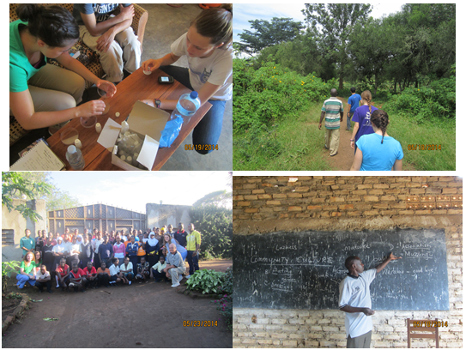
The top two pictures are of our team conducting water tests (left) and exploring the property (right). The bottom two are of us with the school students (left) and learning about the Nakyenyi community culture from Francis (a project partner from BUSODA). These are just a few examples of the activities we did on the trip to better understand our project and the community.

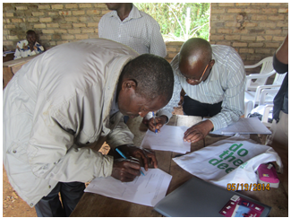
This last photo is of the First Chairman (left) and the Executive Director of BUSODA (Daudi Ssentamu) (right) signing the Project Partner Agreement after we held a community meeting where the community unanimously agreed to support a biogas digester project.

