Instructions for Students
To register for EPICS you will need the list of CRNs for our teams/sections. I have attached that chart and although they are listed in acronyms you can do a search and find the team. If you don’t know what team you want to be on please contact me. The CRNs for the lectures are at the very end of the list.
Both lecture and lab CRNs need to be entered and then you should have no problems.
If your advisor is using the Advisor Course Recommendation Form (Advisor CRF), then electronically pre-loaded courses will be sent to your Student Course Request Form. Otherwise, your advisor will communicate with you on what courses for you to manually enter on your CRF.
If you encounter a problem, please contact me.

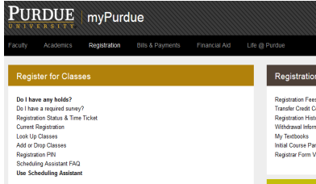
Log in to myPurdue, click on Registration tab, and then select Use Scheduling Assistant. Select appropriate term.

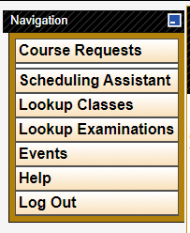
If your advisor uses the Advisor Course Recommendation Form, your courses will auto-load into your CRF and you can simply Submit Requests. Otherwise, you will have to manually add courses using Course Requests.

Add your EPCS course, along with your other courses, in the order your advisor recommended. Click on the magnifying glass on the EPCS priority line, and another box will open with a list of the sections and CRNs and click on the one(s) you need. Refer to the list of CRNs to select the appropriate team lecture and lab. Then click Select.
Students:
Discuss with your advisor the order of priority you enter your courses. This is important for all of your courses, not just EPCS.
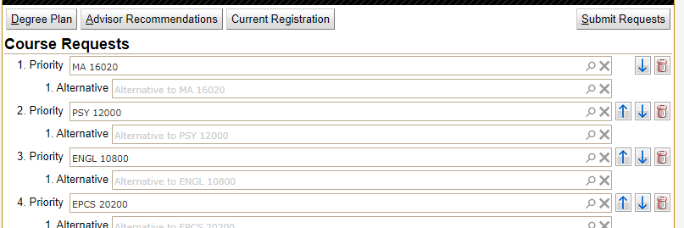
Students:
Discuss with your advisor the order of prior your c

