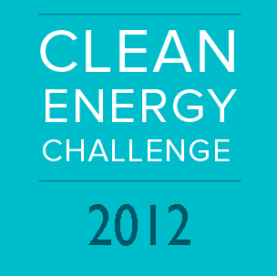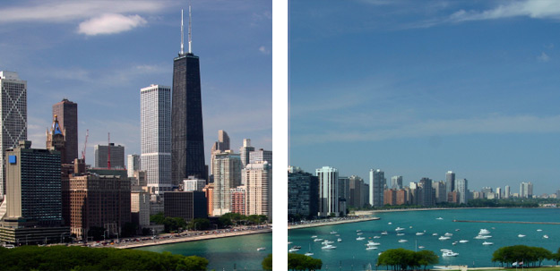

The Clean Energy Challenge is an annual, first-in-class business competition that awards cash prizes to top cleantech entrepreneurs in the Midwest. Applicants compete in two tracks: Early Stage Business and the Student Challenge reserved for best-in-class university spinouts from top tier Midwestern research institutions. Early stage companies will compete for $100,000 in prizes. The Student Challenge offers an additional $100,000 Grand Prize and five (5) $10,000 runner-up prizes for student teams.
Teams competing in the Student Challenge will vie for an opportunity to compete in the U.S. Department of Energy’s first-ever national business competition for university students. Eligibility is limited to applicants from Illinois, Indiana, Michigan, Minnesota, Missouri, Ohio, Kentucky and Wisconsin. One team will receive the $100,000 Grand Prize and will move on to compete in a National Grand Prize competition, organized by the Department of Energy in Washington, D.C in Summer of 2012.
Fall Marketing The Student Challenge will kick-off in October 2011 with a series of networking events throughout the region. This series will bring together speakers from each host university, including representatives from technology transfer, centers of excellence in entrepreneurship & energy, student energy clubs, technology accelerators, as well as local angel and venture investors. Speakers will highlight current developments in local energy innovation, educate students about existing resources and programs supporting entrepreneurship in energy, and promote participation in the Clean Energy Challenge. The series will conclude in mid-November.
Application Process Applications can be submitted starting November 1st, 2011 through the Clean Energy Challenge iStart submission portal at http://cleanenergychallenge2012.istart.org . Teams will be expected to work closely with their university technology transfer office or the appropriate national lab licensing officer to identify a technology to build their application around. Applicants will be asked to provide a brief executive summary describing the problem, the solution, the market, and a preliminary commercialization plan. In addition to the executive summary, teams will be asked to include a link to a 3-minute investor pitch, as well as a brief resume of each team member. Preference will be given to teams that demonstrate clear commitment to entrepreneurship and energy innovation. The deadline for submission is December 5th, 2011.

Semifinalist Selection By December 16th, 2011, the three highest scoring applicants from Illinois, Indiana, Michigan, Ohio, and Missouri will be selected to move onto the semi-finals. An additional three wild-card slots will be open for the top applicants throughout the region. A total of 18 companies will be selected to move onto the semi-finals.
Mentoring Process Mentorship will begin in early January, and will continue through the duration of the competition. Each semi-finalist will be matched with experienced entrepreneurs and technical experts, who will work closely with teams to evaluate and adjust their commercialization strategy and sharpen their investor pitch. Each team will be assigned two mentors – one generalist and one specialist – matched specifically to complement their needs. Mentors will be asked to meet with their teams for a minimum of 1 hour per week for the duration of the mentorship period.
Student groups will also have the ongoing support of their universities, business & entrepreneurial centers, and technology transfer offices as they navigate the application process and prepare for the possibility of presenting at the Challenge in March.
Each week throughout the mentorship period, semifinalists will be required to submit an updated version of their 3-minute investor pitch. Mentors will score semifinalists on a weekly basis until the final competition in March. Eight teams with the highest scores during the mentorship period will move onto the finals, where they will compete for a chance at the Grand Prize, $100,000 in cash and an opportunity to present at the national competition, organized by the Department of Energy in Washington D.C. in the Summer of 2012.
Presentation at the Challenge:
- All semifinalists must submit a final executive summary (3-page maximum)
- All semi-finalists will have exhibition space at the March 1st Showcase
- Top performers will present in a fast-pitch format to a distinguished panel of industry leading venture capitalists, strategic investors, and technical experts

Key Dates

October 25th 12-1pm CST DOE Innovation Portal Webinar

December 5th First-round application deadline

December 16th Semi-finalist notification

January 9th Mentorship period begins

January 27th Semi-final round 1

February 3rd Semi-final round 2

February 10th Semi-final round 3

February 17th Semi-final round 4

February 29th Clean Energy Challenge VIP Reception

March 1st Clean Energy Challenge

