Incomplete mixing in reactive systems - from Lab to Field scale
Diogo Bolster
Associate Professor, University of Notre Dame
11/17/2017, 2.30 PM , Hamp 3153
Interview contacts: Diogo, dbolster@nd.edu

Abstract
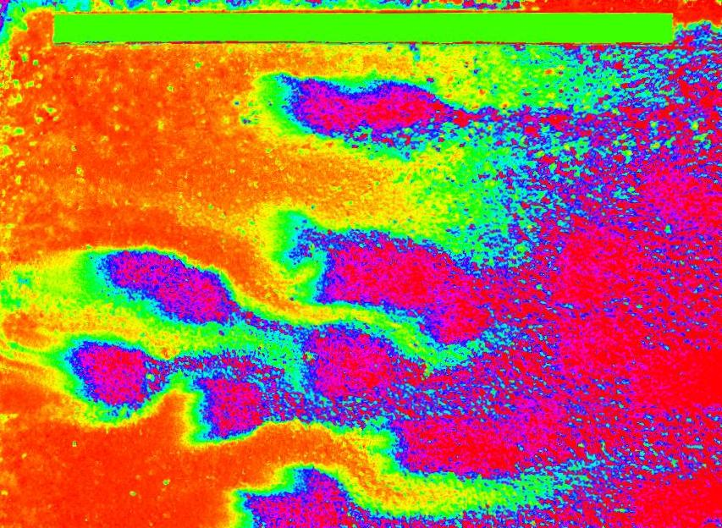
In order for two items to react they must physically come into contact with one another. In the lab we often measure reaction rates by forcing two species to continuously mix together. However, in real systems such forced mixing mechanisms may often not exist and so a natural question arises: How do we take measurements from our well mixed laboratory experiments and use them to make meaningful predictions at scales of interest? In this talk we propose a novel modeling framework that aims precisely to do this. To show its applicability we will discuss it as related to a few examples: (i) mixing driven reactions in a quasi-well-mixed systems (ii) mixing driven reactions in a porous column experiment and (iii) mixing in a highly heterogeneous aquifer with a broad range of velocity and spatial scales.
While this work was originally motivated by chemical reactions in porous media, the modeling framework is much more general than this and should be applicable to a broad range of problems. Also, the term reaction, as defined within our framework, can loosely be defined as an event where two items come together to produce something else; it is not in any way limited to purely chemical reactions.

Brief Bio
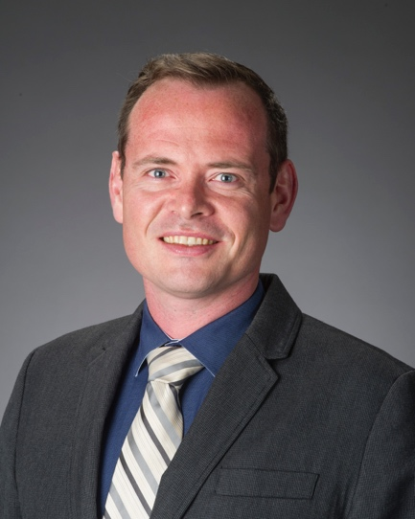
Diogo Bolster is an associate professor in the Department of Civil & Environmental Engineering and Earth Sciences, where he has been a faculty member since 2010. Prior to that he was a postdoctoral researcher at the Politecnico de Catalunya in Spain from 2007. He did his PhD at the University of California in San Diego from 2003-2007 and completed his undergraduate studies in his homeland of Ireland at University College Dublin in 2002. Broadly speaking Diogo is interested in developing mathematical models that describe the transport of solutes in environmental flows, ranging from the indoor environment, to streams and rivers to the subsurface. If it moves in the environment he is interested in trying to describe it. His models aim to balance natural complexity with parsimony.

Details on Diogo’s publications and research interests can be found on his personal website www.nd.edu/~bolster.

