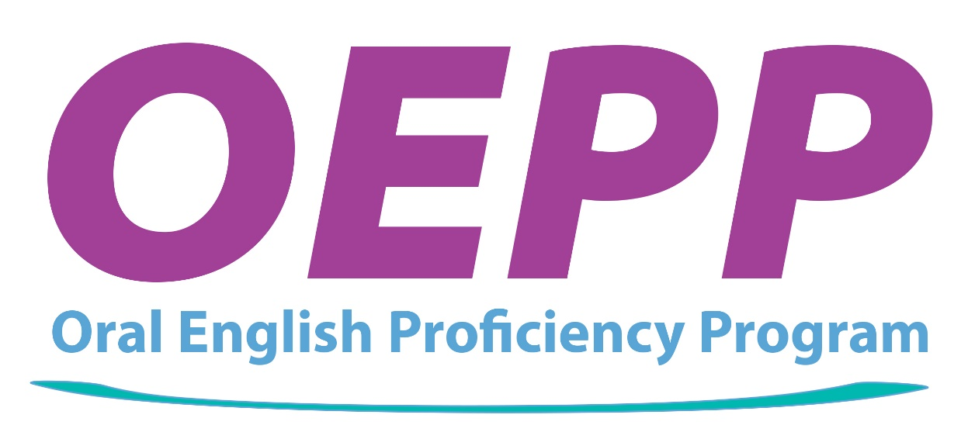

Improve the quality of undergraduate instruction at Purdue

Volunteer for the Oral English Proficiency Program

The OEPP needs volunteers to help international graduate students prepare to become effective teaching assistants at Purdue.

- Chat informally with the international graduate students

- Observe students in ENGL 620 give oral presentations to practice speaking English in a classroom setting. (ENGL 620 is the OEPP’s class for international teaching assistants)

- Participate in a question and answer session and complete a brief written evaluation form.

- You can earn an Intercultural Communication Partner Certificate to build your resume.

All presentations are held in Krannert G21 and G 09 at 9:30, 10:30, 11:30, 12:30, 1:30, 2:30, 3:30, 4:30

Presentation 1: September 9 -12, 2019

Presentation 2: September 30 – October 3, 2019

Presentation 3: October 28-Octobe 31, 2019

Presentation 4: November 20 and 21, 25 and 26, 2019


Register to volunteer: https://volunteer.ace-in-testing.com/

Please use Google Chrome or Mozilla as your web browser,

NOT INTERNET EXPLORER

Questions? Email Beth Lageveen blagevee@purdue.edu

