

Design Document
Team: HFIC
Project: Bili Blanket
Date: 4/22/2016

1 Table of Contents
1 Table of Contents 2
2 Revision History 3
3 Design Status 4
4 Project Charter 5
4.1 Description of the Community Partner 5
4.2 Stakeholders 5
4.3 Project Definition 5
4.5 Expected Semester Timeline 5
5 Semester Documentation (current semester) 6
5.1 Team Member 6
5.2 Current Status and Location on Overall Project Timeline 6
5.3 Goals for the Semester 6
5.4 Semester Timeline 6
5.5 Semester Budget 6
5.6 Transition Report 6
5.6.1 Summary of Semester Progress / Comparison of Actual Semester Timeline to Proposed Semester Timeline 6
5.6.2 Draft Timeline for (next semester) and Relationship to Overall Project Timeline 6
6. Current Design 7
Appendix A: Past Semester Archive 8
A.1 Past Semester 1* 8
A.1.1 Past Team Members 8
A.1.2 Past Timeline 8

2 Revision History
Date | Author | Revisions Made
10/2/2015 | Spencer/Levi | 1
10/5/2015 | Caroline Sherlow | 1
12/4/2015 | Caroline Sherlow | 1
2/22/2016 | Caroline Sherlow | 1
4/15/2016 | Caroline Sherlow | 1
4/20/2016 | Caroline/Spencer | 1

3 Design Status
Phase 6: Service / Maintenance | Status: To be done  Semester: N/A
Phase 5: Delivery | Status: To be done  Semester: N/A
Phase 4: Detailed Design | Status: To be done  Semester: N/A
Phase 3: Conceptual Design | Status: In Process  Semester: Fall 2015/Spring 2016
Phase 2: Specification Development | Status: In Process  Semester: Fall 2015
Phase 1: Project Identification | Status: In Process  Semester: Fall 2015

4. Project Charter

4.1 Description of the Community Partner

Our project partner is a group of students and professors at the Vellore Institute of Technology (VIT). The overall goal is to help improve conditions for infants at the Christian Medical College (CMC) through providing high standards of safe and efficient treatment for infants within the neonatal care unit. The people who will benefit from this project will be CMC staff and the infants who are patients at CMC. Also family members of the children will have peace of mind that their children are in the most pleasant conditions possible.
Ultimately, CMC will receive the improvements that we develop; however, we will be going through the students at VIT. Our team is working toward the VIT mission, which is “to educate students from all over India, including those from the local and rural areas, and from other countries, so they become enlightened individuals, improving the living standards of their families, industry, and society. We will provide individuals’ attention, world-class quality education and take care of character building.”

4.2 Stakeholders

Our official customer is CMC, and we are hoping to deliver low cost solutions and modifications of pre-existing medical devices used at CMC to patients and their families. Stakeholders include: our partner team at VIT, CMC Hospital, and doctors and nurses who would be involved in the project, and the patients and families who are the main target group of the project.

4.3 Project Definition

The project that was being addressed and worked on at the beginning of the 2016 Spring semester was that of a cooling incubator and its ability to effectively treat birth asphyxia. In India many infants suffer from birth asphyxia, a medical condition resulting from deprivation of oxygen to a newborn that can last long enough to cause damage. If not treated the baby will continue to not get enough oxygen and can cause serious brain damage. In India, birth asphyxia is the cause of 28.7% of total infant deaths. The way that the Christina Medical College has been treating birth asphyxia is through the process of therapeutic hypothermia.
The original project was to test and extend the life of the cooling device used to treat children in India suffering from birth asphyxia. The cooling device in use is the Neonatal MiraCradle.
After communication with our community partners, the PCM project was terminated and replaced with a project dealing with phototherapy treatments, also used in the neonatal unit. CMC is interesting in developing a new, more economic model of a Biliblanket – a phototherapy blanket used to treat jaundice in infants. The remainder of the semester was used to research and determine specifications for the project, brainstorm ideas for possible solutions, and design and test a conceptual model, as well as some preliminary testing.

4.4 Outcomes/Deliverables

Produce a prototype that models the conceptual design of the Biliblanket, begin developing testing procedures to be used later on, and continue communication between community partner.

4.5 Expected Semester Timeline

The first few weeks of the semester were dedicated to working on the PCM project, however, the team switched directions half-way through the semester. By the end of the semester, the team wants to have accomplished: Background research and specifications, basic prototyping of the conceptual design, and preliminary testing procedures produced and modeled.
5 Semester Documentation (current semester)

5.1 Team Member
Caroline Sherlow (Project Manager)
Spencer Bockover (Project Manager)
Bharath
Jacqueline Adams
Jeffrey Peng
Nia Hightower (Webmaster)
Pablo Harrison Schwiep VII (Project Archivist)

5.2 Current Status and Location on Overall Project Timeline
Our team was in the research/testing phase at the beginning of the semester when working on the PCM project. After changing to the Biliblanket project, the team has stayed primarily in the specification phase, with some work in conceptual design and basic prototyping.

5.3 Goals for the Semester

Long term goals include:
- Continuing to develop communication with project partners
- Develop a higher-functioning prototype
- Further develop and refine testing procedures
Short term goals include:
- Modeling the conceptual design and testing procedures
- Communicating with our project partner through weekly emails and conference calls

5.4 Semester Timeline
N/A

5.5 Semester Budget
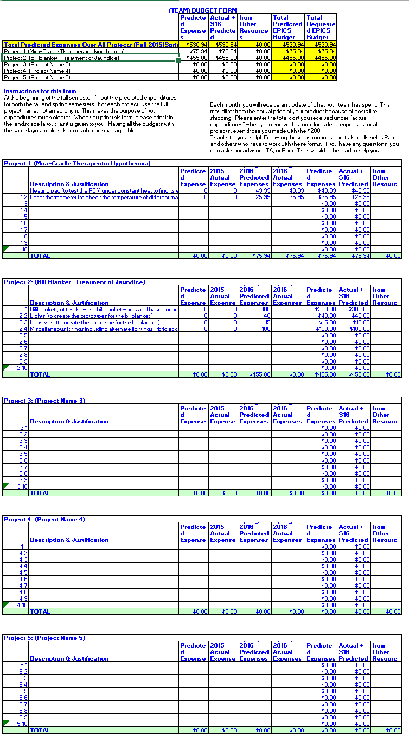

6. Current Design

Bilirubin/Biliblanket Specification Document

Jaundiced Information
Infants who suffer from jaundice suffer due to a buildup of bilirubin in the blood. Bilirubin is one of the products of the decomposition of red blood cells. Infants are more jaundice prone due to the short turnover time for red blood cells. The turnover time for red blood cells in adults is 120 days as opposed to the 70 days in infants.
Jaundice Treatment
A commonly used treatment for infant jaundice is phototherapy. By exposing infants to light of a certain wavelength and intensity of light the infants will get better. Phototherapy is an effective and widely accepted treatment for infants suffering from jaundice. Phototherapy cures jaundice by causing a chemical reaction within the blood that allows the bilirubin to be processed as if the liver was processing it. The infants skin absorbs the blue light and then the light causes a chemical reaction in the blood getting rid of the bilirubin. The phototherapy treatment does the job of the human liver until the liver can begin to work again.
Problem Statement
The solutions that currently exist in India for treating jaundice are expensive and not suitable for all settings. Working with the students at VIT our teams goal is to create a new phototherapy treatment for children in India. The treatment needs to not only cure jaundice but also be an affordable option for both rural and urban settings.
Treatment Specifications
Light: In order for the treatment to be successful the light has to meet certain requirements. The intensity of the light must be about 29,000 Lux, the treatment that is used in most hospitals both domestic and international use halogen bulbs or a BiliBlanket as phototherapy treatment. Also the lights used for treatment must have a wavelength of 460-490 nm. This wavelength coincides with a blue light, however it is important to keep in mind that not all blue lights have the intensity needed.
Safety: The light will have direct contact with the skin and needs to not create heat. If heat is created by the solution, then it could cause harm to the infant or cause a fire risk to the blanket. Therefore, the blanket can have no heat transfer while giving direct light contact to the infant.
Duration: Phototherapy treatment can be used for days at a time due to its noninvasive nature. The solution should last for at least 12 hours without needing a battery change. The solutions being used in the hospitals are connected to a power source so do not need to worry about battery life. Ideally our solution would have a long battery life as it does not need to be replaced frequently.
User Specifications
The solution needs to meet the needs of infants across India, therefore it will need to be adjustable so that the smallest and largest of infants can be effectively treated. Below is a chart of the lowest and highest heights and weights of infants in India.
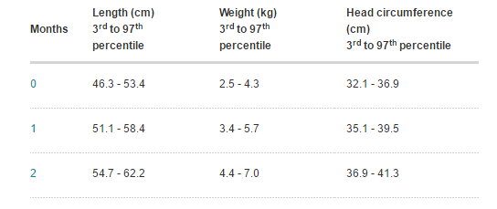
(Baby boys' growth chart: 0 to 12 months. (n.d.). Retrieved April 18, 2016, from http://www.babycenter.in/a1052194/baby-boys-growth-chart-0-to-12-months)
Conceptual Design
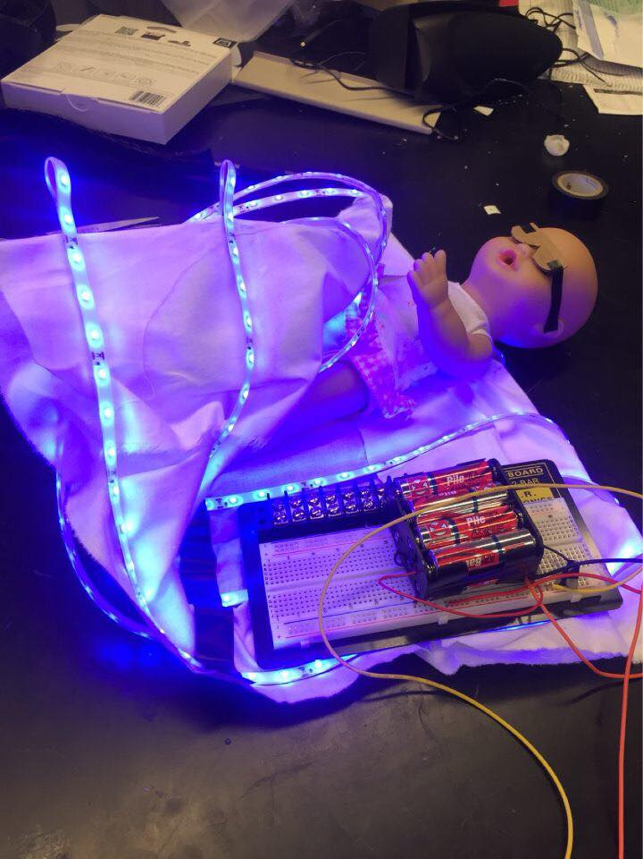
The team developed a conceptual design of the Biliblanket system, pictured above. Blue LED lights were used to model the light source, fabric to model the blanket material, and a baby doll to model the patient.
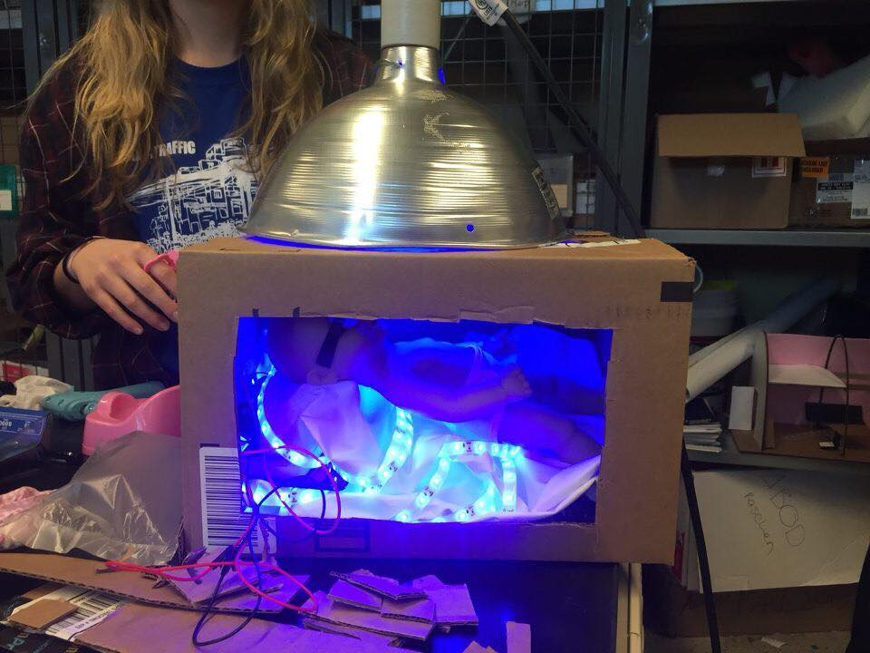
The team has also begun basic testing procedures, modeled above. Factors to be tested include: light intensity, safety of patient, and heat of exposure.

Appendix A: Past Semester Work
Our group was given two tasks by the students at VIT in regards to incubators. We were asked to focus on heating children more gradually and enhancing the cooling system used at the hospital. This semester we have focused almost entirely on the cooling system. The material that we are working with is a phase changing material that helps to keep the babies temperature at a constant low temperature; however the phase changing material has two drawbacks. The first drawback is that it does not cool the child fast enough. We do not have specifics on how fast the child needs to be cooled but the CMC doctors are not satisfied with the current cooling rate. The second issue is that the phase changing material needs swapped out too often which results in too much temperature variation for the child. We were specifically asked to address both of these issues by the VIT students.
The issue of rapid cooling is what we have spent the least amount of time on. In our preliminary research, we discovered options such as water-cooled blankets to cover the baby with or in low-tech circumstances surrounding the baby with cooled water bottles. The drawback to blankets is they interfere with baby monitoring devices such as electrodes and IV’s. Also, there needs to be a safety mechanism to ensure the water flowing through the blanket remains a safe temperature for the baby. Cooled water bottles can be implemented in situations where there is an emergency and no technologically superior alternative is available, however it is the least consistent as far as maintaining a constant core temperature. We have not yet spent a lot of time developing our own unique solution to the rapid cooling problem.
The issue of maintaining a constant temperature is what we have spent the majority of our time investigating. In hospitals in the United States babies with birth asphyxia are treated with a cooling blanket described above that keeps cooled water consistently flowing through the blanket at a constant temperature. We want to maintain the phase changing material system that CMC is already using, so we came up with the idea to use this type of heat exchanging system on the phase changing material instead of using it on the baby directly. The problem with the phase changing material occurs when all of the material has converted from one phase to another. Once all the material is converted, it heats up like any other material. If we could run cool water around the outside of the phase changing material to help keep it at its transformative (eutectoid) temperature then maybe the phase changing material pads would not need to be changed out as often, or at all. This is our most promising design solution, but we need a lot more information before we can begin testing.

