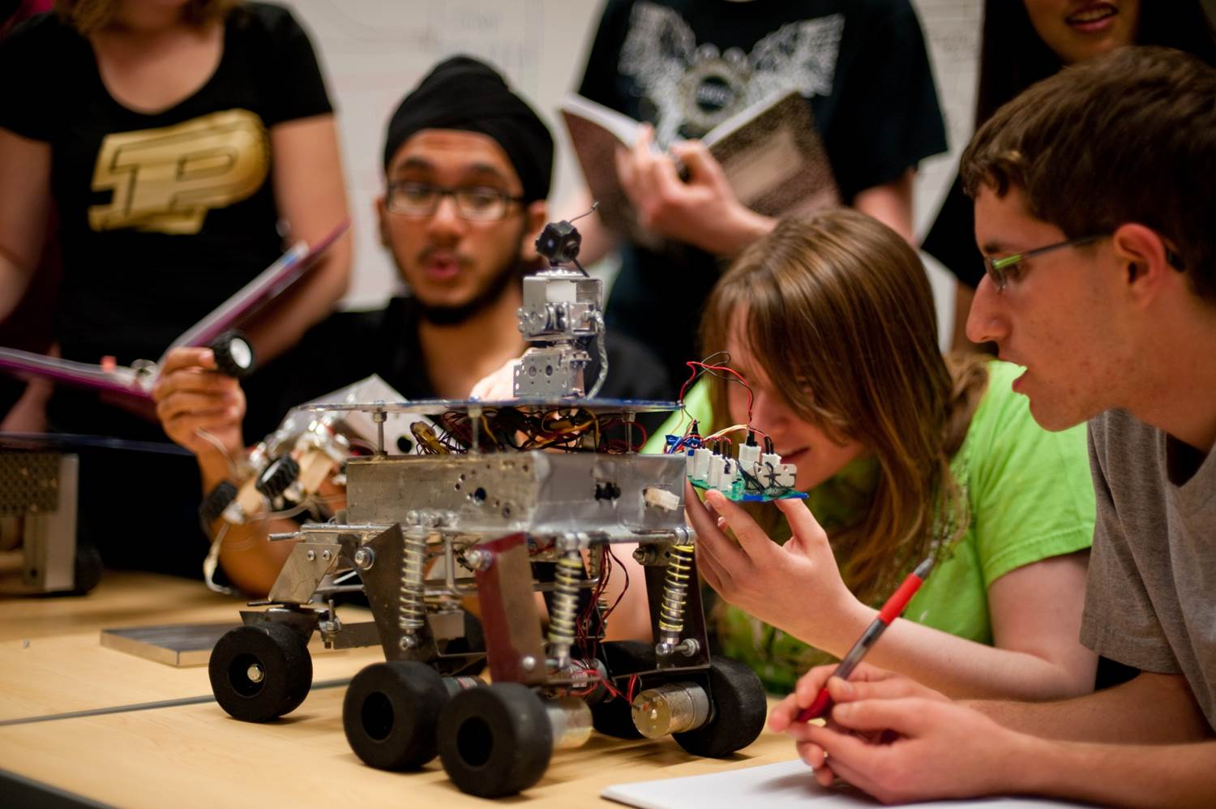
CAD Engineer Wanted
The Wolf Park team (WOLF) is looking for a new member to join the team next semester to assist in the design of an interactive exhibit.
- Prefer experience designing in Inventor or Solidworks
- Must be adept at working in teams
- Must be available for the team meeting Fridays 1:30-3:20

Interested students should enroll in the WOLF team EPICS course. See http://bit.ly/JoinEPICS or email epics@purdue.edu for details.
Resume looking a little empty?
Join EPICS!

