EMBRIO MID-YR PROGRESS REPORTS – Due March 31
Sept 2021 - March 2023/ 18 Months

Background
The aim of the NSF Biology Integration Institutes is to bring researchers together around the common goal of understanding how the processes that sustain life and enable biological innovation to operate and interact within and across different scales of organization, from molecules to cells, tissues to organisms, species, ecosystems, biomes, and the entire Earth.

Funded in 2021, the EMBRIO BII seeks to determine how living systems integrate chemical and mechanical stimuli to develop responsive phenotypes that coordinate cell and tissue structures for survival and function. The Institute aims to reveal how multiple signals are integrated, organized, and used to coordinate a survival response that requires remodeling and to reveal whether this multilayered integration is conserved across kingdoms. The EMBRIO Institute embodies a research and education enterprise in which members share a collective sense of ownership and desire for professional and personal growth to address challenges across biological kingdoms and levels of organization; transcend disciplines; lower barriers to participation by all scientists; and serve as a collaborative model to solve foundational problems in integrative biology and education.

The Institute integrates biology, computation, imaging, modeling, simulation, education, and outreach encompassed in three biological thrusts, a Core data, modeling, and simulations thrust, and an educational research thrust.
Thrust 1: Establish whether the principles and signaling networks in individual cells and cell-to-cell communication systems constitute a Rules of Life that then translate to larger, multi-cellular systems.
Thrust 2: Establish whether the principles and signaling networks in single cells and across tissues constitute a Rules of Life for communicating responses to biotic and abiotic stimuli.
Thrust 3: Establish whether the principles and signaling networks across tissues constitute a Rules of Life compared to single cells or tissue type.
Thrust 4: Identify and implement best practices in curriculum, training, and broadening participation to support learning and meaningful engagement and participation in integrative biology research.
Core Thrust: Integrates with the other thrusts modeling and simulation, data integration, and technology support structure.
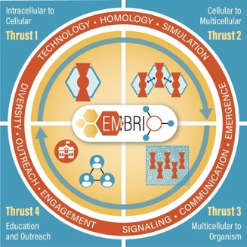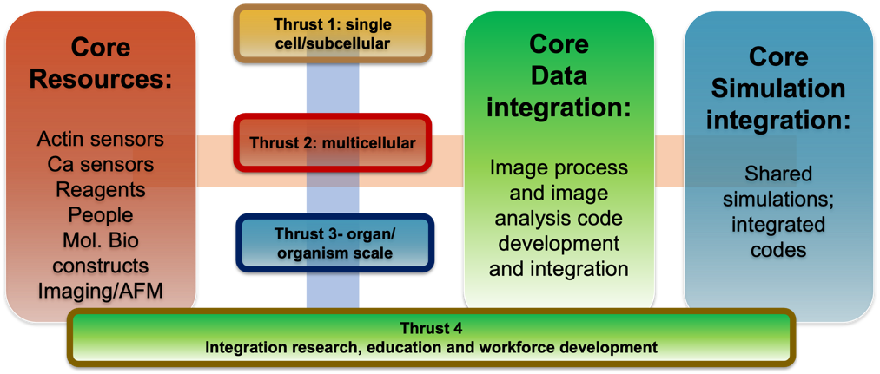
Horizontal and Vertical Integration

Investigator Progress Reports – Due March 31 – emailed to brent (laddb@purdue.edu)
A progress report covering the period of Sept 2021 – March 2023 from each investigator lab is requested aligning with upcoming Y3 budget decisions and annual reporting to NSF. The report should be a maximum of 3 pgs. Please follow the outline below for your report:

Top of 1st Page:
- Investigator name, email, discipline, institution, lab website address
- List Thrust #’s & Project Title(s) that your lab is leading or collaborating
- Postdoctoral Fellow(s) with email, department: name and institution of co-advisor if applicable
- Graduate Student(s) name, email, department, name and institution of co-advisor

Part I. Research Accomplishments (use bullet points. important: for each bullet point attach name(s) of your lab personnel responsible. If involved in more than one project, please attach project thrust ID for each bullet point, e.g., Project 1A)

**Review specific objectives per established thrust project as reported to NSF in 1st annual report (pgs. 9 – 14) available on Box > ANNUAL REPORTING > BII NSF Annual Report 2022. Direct link

- What has been accomplished by your lab in the first 18 months (Sept 1 2021 – March 1 2023) against the project objectives?
- What is yet to be accomplished by your lab prior to the end of Y2 March 1 2023 – August 31 2023?
- Significant results your lab has been involved in producing thus far (graphs and images welcome).

Part II. Integration
- Highlight activities and accomplishments that demonstrate your program's integration within the institute and state which other groups you are working with. {e.g. data sharing with Core, collaboration across scales and/or kingdoms, parameterization and simulations with Core, organizing and running journal clubs or working groups, development of new shared resources and tools, etc.}.

- What activities has your lab engaged in that have integrated Thrust 4 including education, training, and broadening participation {e.g., mentored summer research interns, organized workshop session, taught course, major advisor for underserved minority graduate student, etc.}.

Part III. Products
Scholarly products produced {peer-reviewed journal and conference papers, pre-print papers, books or book chapters, seminars and presentations, thesis dissertations, technologies or techniques, white papers, etc.}

