

Wednesday, September 13, 2023
9:30 – 10:20am, MJIS 1001 or via zoom
Students registered for the seminar are expected to attend in-person.

https://purdue-edu.zoom.us/j/5593290378?pwd=eFBOZFlNTU50ZDA2S2gwcnpyOWIwUT09

“Imaging Genetics: Dynamic Gene Control in Space and Time”

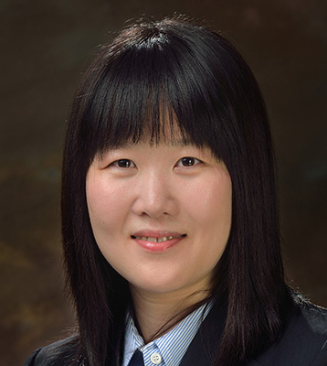

Bomyi Lim, Ph.D
Department of Chemical and Biomolecular Engineering,
Department of Cell and Developmental Biology,
Perelman School of Medicine, University of Pennsylvania

Abstract: Proper gene control across space and time is crucial for the seamless execution of various cellular functions, as too much or too little gene expression in the wrong place or time leads to developmental defects and disease phenotypes. While the importance of gene regulation is well acknowledged, systematic characterization of dynamic gene control is lacking. What is the “normal” range of gene expression, and how does transcriptional kinetics play a role? We employ quantitative live imaging to examine the structure-function relationships of genome topology and gene activity and ultimately relate it to phenotypes. We first systematically varied the distance and orientation between an enhancer and the target promoter and analyzed the changes in transcriptional dynamics. To gain further insights into the kinetics of E-P interactions, we employed the trans-activation (transvection) assay and utilized the DNA and RNA labeling to measure the long-range E-P interaction kinetics and its relationship with transcription. Our study provides a comprehensive characterization of the E-P interaction dynamics required for transcription and normal development

Biography: Bomyi Lim obtained B.S. in Chemical and Biomolecular Engineering from University of Pennsylvania in 2010. Bomyi received her Ph.D. in Chemical and Biological Engineering from Princeton University in 2015. She worked as an NIH F32 postdoctoral fellow at the Lewis-Sigler Institute of Genomics at Princeton University between 2016-2017. In 2018, she joined University of Pennsylvania as an Assistant Professor of Chemical and Biomolecular Engineering. The Lim lab focuses on characterizing the normal range of gene expression kinetics that ensures normal development, using a combination of genome editing, quantitative live imaging, and mathematical modeling. Bomyi received R35 Maximizing Investigators’ Research Award (MIRA) for early-stage investigators in 2020 and the NSF CAREER award in 2021.

~ BME Host: David Umulis ~

