

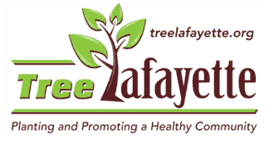

ARBOR DAY
Tree Planting

This Arbor Day the Chemical Engineering GSO is working with Tree Lafayette to plant trees along the new Crosser Softball Complex in Lafayette.

When? April 28th, 2018 9am
Where? Crosser Softball Complex (link)
What to bring? Good shoes and clothes you can get dirty (they will provide tools and trees!)

Please sign up in this link

