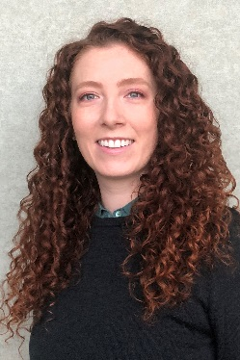
Sydney Hollingshead, Ph.D.
Development Engineer, Cook Biotech, Inc.
Sydney works as a development engineer for Cook Biotech Inc. Cook Biotech creates medical devices that support the regrowth of healthy patient tissue in both surgical- and disease-caused wounds. As a development engineer, Sydney contributes to the discovery and innovation of new medical device technologies. Sydney evaluates potential technologies for their scientific rigor, patient risk, and scale-up and manufacturing practicality and safety. In addition to product research and development, Sydney designs equipment and develops processes for the scale-up of device manufacturing. Sydney’s team is currently dedicated to product development and process engineering scale-up of a novel product line, including full-scale green field plant standup.
Sydney received her Ph.D. in 2018 from Purdue University Chemical Engineering. Her thesis, “Biomimetic Polymers for Medical Applications”, was composed of studies in soft tissue protein- and polymer-based surgical adhesives. She has extensive experience fermenting recombinant proteins and used a semi-pilot scale (10L) bioreactor to produce a recombinant elastin-like protein from E. coli for use in medical devices. She also has experience working with mammalian cell lines for cytocompatibility evaluations of medical devices. She served as safety officer in her research group, under advisor Dr. Julie C. Liu, and supervised safety inspections and maintenance for biosafety level 1 and 2 laboratories. Sydney lead her research group through several lab safety incidents related to biological and chemical hazards. For her work as safety officer, Sydney received the Excellence in Safety Award from Purdue Chemical Engineering in 2018.
Previously, Sydney worked as a graduate engineering co-op at Exxon Mobil in Paulsboro, NJ, researching the rheology of novel polymer additives for engine lubricants. She also worked as a research intern at TriSep Corporation in Goleta, CA, developing improved manufacturing techniques for thin-film polymer filtration membranes. Before her graduate research, Sydney worked as an undergraduate researcher with Dr. Michael Chabinyc studying organic photovoltaic processing techniques, and with Dr. David Cleveland studying the sustainability of local food and agriculture production systems. She has also held several leadership positions in outreach organizations, including president of the Purdue Chemical Engineering Graduate Student Organization, president of the UCSB chapter of the Society of Women Engineers, workshop leader with Purdue Women in Engineering, and founder and leader of Cook Biotech Professionals in Career Development.
Sydney holds a B.S. in Chemical Engineering from the University of California, Santa Barbara. She has been selected as part of Conexus Indiana’s inaugural Rising 30 class in advanced manufacturing and logistics. She has been awarded the Young Investigator Award from Baxter International Inc. in 2017, the Marilyn Forney Graduate Student Trailblazer Award from the Purdue Pipeline Center in 2017, and an Outstanding Student Scholarship from Purdue University College of Engineering in 2016. She currently serves as a board member of the Purdue Chemical Engineering Industrial Advisory Council, representing Cook Biotech Inc.

