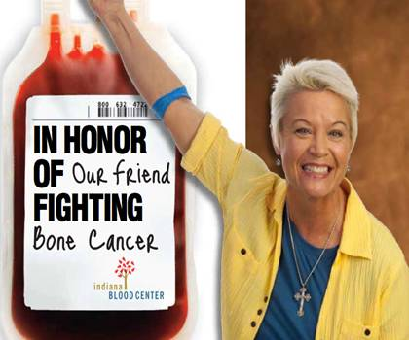
Purdue Summer Blood Drive
Monday, June 11, 2012
11:30-4:30PM
Bloodmobile in Stewart Center Bike Lane

Click here to sign up!
Eligibility
Most people are eligible to donate. There are very few causes for deferral and very few medications that are not acceptable. Donors cannot be taking antibiotics for infection. Cancer patients must be one year cancer free. Heart patients must be 6 months symptom free. Diabetics can donate. It is recommended that donors have a light snack before donating DO NOT FAST – feel free to have some of our juice and cookies. Be sure to bring your picture ID!
Not sure if you are eligible to donate? Email Steve Dieringer.
Indiana Blood Center is charged with collecting 550 units every day to be able to supply over 60 Indiana hospitals. Your donation will save up to 3 lives. Every drop counts!
More questions? Feel free to contact Courtney Adkins(cadkins@indianablood.org).

